




AXMEDIS

Automating Production of Cross Media Content
for Multi-channel Distribution
www.AXMEDIS.org

AXMEDIS, DMP, MPEG-21
Analysis and Comparison
Version: 1.7
Date: 27/05/2005
Responsible: DSI
Project Number: IST-2-511299
Project Title: AXMEDIS
Deliverable Type: report (internal description)
Visible to User Groups: NO
Visible to Affiliated: NO
Visible to the Public: NO
Visible to DMP board only

Contributors in AXMEDIS:
DSI (Nesi, Bellini, Rogai, Vallotti), FUPF (Delgado, Llorente, Rodriguez)

Version corrected by Nesi after the meeting in Florence: 14/05/2005

Table of Content

1 Introduction 3
2 Comments on General Architecture of DMP and AXMEDIS 4
3 Relationship between DMP and AXMEDIS on Content Representation 13
4 Relationship between DMP Profile of MPEG-21 IPMP Components and MPEG-21 IPMP Components specification 15
4.1 Governed elements 16
4.2 Location of licenses in the Content 16
5 Relationship between DMP Profile of MPEG-21 IPMP Components and AXMEDIS and MPEG-21 IPMP itself 17
Relationship among MPEG-21 REL, DMP Profiles of MPEG-21 REL and AXMEDIS 18
5.1 MPEG-21 REL Core 18
5.2 MPEG-21 REL standard extension 19
5.3 MPEG-21 REL multimedia extension 19
5.4 DMP Represent Rights Expressions Schema 20
Annex I - Identification of content, licenses, devices and domains in DMP 22
Content identification 22
License identification 22
Device identification 22
In AXMEDIS 23
Domain identification 23
Meeting of 14/05/2005 23
AXMEDIS Actions 23

Introduction
This document presents a first study about the similarities and differences among the DMP specifications, MPEG-21 and AXMEDIS.

First of all we present the relationship among AXMEDIS, DMP and MPEG-21 in terms of
- General architecture: DMP and AXMEDIS
- Content representation, DMP and AXMEDIS
- DMP Profile of MPEG-21 IPMP Components and MPEG-21 IPMP Components specification
- DMP Profile of MPEG-21 IPMP Components and AXMEDIS IPMP and protection aspects specification
- MPEG-21 REL, DMP Profiles of MPEG-21 REL and AXMEDIS
- DMP specification of Identification of content, licenses, devices and domains in DMP

Comments on General Architecture of DMP and AXMEDIS

The following table reports the mapping of the DMP major technologies/features and their schedule in the phases of the DMP (those features are called Tools in DMP terminology), with the AXMEDIS elements and their module and realization schedule.

It should be noted that, AXMEDIS plan to include/produce a large number of software tools that are not mentioned neither included into the DMP architecture and that the following table report only those that are mapped into those of DMP neglecting all the others.

In some cases, when the AXMEDIS additional technologies have been supposed to be very relevant also for DMP, a line has been added and marked in yellow.

Other point marked in green are those in which we don’t have yet a solution in term of technology into AXMEDIS or for which the AXMEDIS solution is different or partial with respect to that of DMP.

In Column DMP Tools some comments have been included in round brackets ().
In Column DMP Tools some addition tools have been added from AXMEDIS in Yellow.
In Column DMP III when R or C or R+C has been added means that AXMEDIS has the knowledge to Contribute to Requirements, and to the Call with tools respectively.

Column AXMEDIS When describes when the formalisation of that format/protocol is accessible and in particular:
- FR: means ready format or web service into the AXMEDIS specification and a specific action started for the implementation of that technology. In some cases, AXMEDIS has already a prototype and the basic technology. FR for normative work is enough. A first release of most of the Tools is planned to be ready for November 2005. That date has been omitted to avoid of writing the same 11/05 in all boxes.
- TR: means ready tools and technology in a prototype that work since it has been validated in the whole architecture. A first release of most of the Tools is planned to be ready for November 2005. That date has been omitted to avoid of writing the same 11/05 in all boxes.
- P or F (MM/YY): means tools and technology or Format ready in the specified date. A first release of most of the Tools is planned to be ready for November 2005. That date has been omitted to avoid of writing the same 11/05 in all boxes.

According to AXMEDIS terminology:
- an object is an AXMEDIS object that is substantially a specialized version of MPEG-21 digital item.
- An Action is an Event in the MPEG-21 terminology.

DMP |  |  |  |  |  |  |  |  |  |  | AXMEDIS
Category |  | Tools/ major functionalities |  | I |  | II |  | III |  | comment |  |  | where |  | when
Represent |  | It is coding
 |  | Represent Metadata |  | X |  |  |  | R+C |  | DC+MPEG7+AXInfo++ |  |  | AXInfo, AXOM |  | FR+TR
 |  | Represent Content |  | X |  |  |  | R+C |  | MPEG-21 |  |  | AXOM (See CE MPEG 21 started in Busan meeting of MPEG) |  | FR+TR
 |  | Represent Rights Expression |  | X |  |  |  |  |  | REL, RDD, ….(Mi3P in the figure if needed) |  |  | DRM Support, MPEG-21 REL based, restricted with respect to MPEG-21 |  | FR+TR
 |  | Represent Use Data |  |  |  |  |  | X++ |  | Action Log, it is an evolution of MPEG21 event reporting, comments and more IDs are in the AXCS Action Log |  |  | Action Log, AXCS DB, etc. |  | FR
 |  | Represent Use Data in the storage |  |  |  |  |  |  |  | Representing events in DB or in sending them out from the terminal |  |  |  |  | FR
Identify |  | It is a coding
 |  | Identify Content |  | X |  |  |  |  |  | UUID, fingerprint |  |  | AXOID+fingerprint, AXCS for the registration, AXIDG |  | FR
 |  | Identify License |  | X |  |  |  |  |  | UUID, fingerprint/signature |  |  | AXLID, Fingerprint, AXIDG ? |  | FR
 |  | Identify User |  |  |  |  |  | X |  | UUID + information from the OS |  |  | AXUID, AXCS for the registration, AXIDG, web service |  | FR
 |  | Identify Device |  | X |  |  |  | R+C |  | AXTID, AXRID, AXTTID as UUID+4code, HW and SW profile, fingerprint |  |  | Protection Processor for estimation, AXCS table of devices |  | FR
 |  | Identify Use Context (nationality, location, etc., all statically imposed at the installation) |  |  |  |  |  |  |  | IP address, other status conditions to be stated in the Tools profile at the installation (in the disco, in the home, in the office, in car, etc.)  Dynamically.  In AXMEDIS is missing: status, role, etc.. |  |  | Protection Processor, AXCS, user registration |  | FR
 |  | Identify Domain |  | X |  |  |  |  |  | Textual name for the domain, UUID+4code as device, HW and SW profile, fingerprint |  |  | Protection Processor, AXCS for the registration of domains |  | FR
 |  | Identify Resource Format |  |  |  |  |  |  |  | As MIME type, Technical metadata in AXInfo, + MPEG7 |  |  | AXInfo, AXCS for the registration of objects |  | FR
 |  | Identify Device Capability |  |  |  |  |  |  |  | HW and SW profile, fingerprint passing |  |  | Protection Processor, AXCS table of devices |  | FR
 |  | Identify Tool |  |  |  | X |  |  |  | AXTTID, etc.., Fingerprint, SW profile, DLL |  |  | Protection Processor, AXCS for the registration of SW tools |  | FR
 |  | Identify Distributor, |  |  |  |  |  | C |  | AXCDID, etc. |  |  | AXCDID, AXCS for the registration |  | FR
 |  | Identify Producer |  |  |  |  |  |  |  | AXCPID, etc… |  |  | AXCPID, AXCS for the registration |  | FR
Assign |  | It is protocol
 |  | Assign Identifier |  |  |  |  |  | R+C |  | AXOID Generator, General ID production, local ID generator for Temporary IDs for objects that cannot get out of the AXMEDIS factory. AXMEDIS has a WS formalisation of this protocol |  |  | AXMEDIS Editor, AXOM, AXCS |  | FR
 |  | Assign Fingerprint as identifier |  |  |  |  |  | R+C |  | Assign Fingerprint, Fingerprint Technology, AXMEDIS has a WS formalisation of this protocol |  |  | FP module, AXCS stores them |  | FR
 |  | Assign Descriptor (based on external authority |  |  |  |  |  |  |  | Descriptors/fingerprint extraction technology for Video, Audio, Document, Multimedia, etc.  Missing external authority |  |  | AXMEDIS Editor, descriptor DLLs, many other tools In AXMEDIS the descriptors can be estimated by Certified tools in any AXOM based tool/device for AXMEDIS object authoring |  | FR
Package Content |  | It is a code and protocol
 | File |  | X |  |  |  |  |  | MPEG21-DID, MPEG21 File Format |  |  | AXOM |  | FR
 | Stream |  |  |  | X |  |  |  | Missing up to now |  |  | missing up to now
Authenticate | It is code and protocol
 | Authenticate User |  |  |  |  |  | X R+C |  | User Certification and Authentication |  |  | Protection Processor |  | FR
 | Authenticate Device |  | X |  |  |  |  |  | Device Certification and Authentication |  |  | Protection Processor |  | FR
 | Authenticate Domain |  | X |  |  |  |  |  | See the above Certification and Authentication |  |  | Protection Processor |  | FR
 | Authenticate Tools |  |  |  | X |  |  |  | SW tool Certification and Authentication |  |  | Protection Processor |  | FR
Revoke | It is code and protocol
 | Revoke Device |  |  |  | X |  |  |  | Device Black List into the AXCS DB |  |  | AXCS |  | FR
 | Revoke License |  |  |  |  |  | R+C |  | License Black List into the AXCS DB |  |  | AXCS |  | FR
 | Revoke User (as Producer, end users, etc..) |  |  |  |  |  | R+C |  | User Black List into the AXCS DB |  |  | AXCS |  | FR
 | Revoke Content (an AXMEDIS Object for instance) |  |  |  |  |  | R+C |  | Content/Object Black List into the AXCS DB |  |  | AXCS |  | FR
 | Revoke Domain |  | X |  |  |  |  |  | Domain Black List into the AXCS DB |  |  | AXCS
Verify | It is protocol
 | Verify Data Integrity |  |  |  |  |  | R+C |  | Hash code on the client side, Fingerprint on the server |  |  | Fingerprint estimation and AXCS, Protection Processor |  | FR
 | Verify Device Integrity |  |  |  |  |  | R+C |  | SW/HW Fingerprint, |  |  | Fingerprint estimation and AXCS, Protection Processor |  | FR
 | Verify Tool Integrity |  |  |  |  |  | R+C |  | Hash code on the client side, Fingerprint on the server |  |  | Fingerprint estimation and AXCS, Protection Processor |  | FR
 | Verify Metadata as belonging to the content |  |  |  |  |  | R+C |  | Hash code on the client side, Fingerprint on the server |  |  | Fingerprint estimation and AXCS, Protection Processor |  | FR
Certify | It is protocol
 | Certify Work |  |  |  |  |  |  |  | Producer Collecting Society staff, not in the aim of AXMEDIS |  |  | Producer Collecting Society staff, not in the aim of AXMEDIS
 | Certify Content as Objects |  |  |  |  |  | R+C |  | Certification of AXMEDIS objects, Fingerprint, Metadata certification? |  |  | AXOM/AXINFO, Fingerprint of Metadata |  | FR
 | Certify User |  |  |  |  |  | R+C |  | User Certification and Authentication, see also registration |  |  | Protection Processor, AXCS, a web service is available and a DB
 | Certify Producer |  |  |  |  |  | R+C |  | User Certification and Authentication, specific IDs are present in AXMEDIS since specify functionalities are present in AXCS for them |  |  | Protection Processor, AXCS
 | Certify Distributor |  |  |  |  |  | R+C |  | User Certification and Authentication, specific IDs are present in AXMEDIS since specify functionalities are present in AXCS for them |  |  | Protection Processor, AXCS
 | Certify Metadata |  |  |  |  |  | R+C |  | Certification of AXInfo |  |  | Protection Processor, AXOM/AXINFO, Fingerprint of Metadata
 | Certify Author |  |  |  |  |  |  |  | Producer Collecting Society staff, not in the aim of AXMEDIS |  |  | Producer Collecting Society staff, not in the aim of AXMEDIS
 | Certify Device |  |  |  |  |  | R+C |  | Device Certification and Authentication, HW and SW fingerprint, local verification and remote verification |  |  | Protection Processor, AXCS as counterpart, Web service, etc. |  | FR
 | Certify Tool |  |  |  |  |  | R+C |  | Device Certification and Authentication, HW and SW fingerprint local verification and remote verification from AXCS supervision. Each Additional Tool or DLL has to be certified as well |  |  | Protection Processor, AXCS as counterpart, Web service, etc. |  | FR
Manage |  | Means produce, collect and provide??
 |  | Manage Key |  | X |  |  |  |  |  | Key production, key caching, IPMP description |  |  | DRM support and Protection support
 |  | Manage Protection Information |  |  |  |  |  | R+C |  | Dymanic management of Protection Information (IPMP information) |  |  | AXCS and Protection Processor, Protection Information Editor and Viewer, etc. Protection Manager Support Server |  | FR
 |  | Manage Protection Information on Clients |  |  |  |  |  | R+C |  | Secure cache on AXMEDIS clients |  |  | Protection Manager Support Client and Protection Processor |  | FR
 |  | Manage Domain (it includes in DMP also the storing of content) |  | X |  |  |  |  |  | AXMEDIS Domain Manager as independent Tool to be certified as well, not for storing content |  |  | AXMEDIS Domain Manager |  | FR
 |  | Manage Content |  |  |  |  |  | R+C |  | AXMEDIS database, Loader and Saver, scalable, web service, Query Support |  |  | AXDB Manager, query support, etc. |  | FR
 |  | Manage Device Capability |  |  |  |  |  |  |  | Device and tool profile |  |  | Protection Processor |  | FR
 |  | Manage Use Data Confidentiality (including negotiation of their value) |  |  |  |  |  | X |  | Action Log Server DB and Accounting manager.  In AXMEDIS the user has not possibility of deciding much. |  |  | AXCS + Accounting manager and DB: Producer, Distributor, Collecting Society., etc.. see only a part of the whole Log |  | FR
Access |  | It is a protocol
 |  | Content |  | X |  |  |  | R+C |  | WEB services of AXMEDIS tools, AXMEDIS loader and saver, etc. |  |  | AXDB, AXMEDIS query support, etc. |  | FR
 |  | License |  | X |  |  |  | R+C |  | WEB services of AXMEDIS tools |  |  | AXMEDIS DRM editor, AXDB db for storing licenses, PMS support |  | FR
 |  | Protection Information |  |  |  |  |  | R+C |  | WEB services of AXMEDIS tools |  |  | AXMEDIS Protection Information Editor, AXMEDIS CS for storing Protection information, WEB service |  | FR
 |  | Tool |  |  |  | X |  |  |  | Access to Editors, players, DLL, they have to be certified, it also related to M3W components trading |  |  | Protection Processor
Process |  | Functional protocol
 |  | Backup (it is intended the protocol to make a backup object that cannot be used a real copy, but it has to be restored to become usable again) |  |  |  |  |  | X R+C |  | In a restricted usage such as in the Saver of the AXMEDIS database when a content is stored inside there for a Domain of AXMEDIS factory, It has a sense only for Governed Objects with Protection Information Inside, that are objects with Copy restriction in the license |  |  | AXOM, AXDB
 |  | Binarise XML |  | X |  |  |  |  |  | XML to BIN, BIN to XML |  |  | AXOM
 |  | Bind (it is intended the production of more complex objects with links) |  |  |  | X |  |  |  | Many tools can do it, mainly all AXOM based tools. |  |  | AXMEDIS Editor and AXCP tools and GRID with AXMEDIS Engine, etc. |  | FR
 |  | Copy (process of making a copy. It has several implications if the object contains also license and protection information, etc.) |  | X |  |  |  |  |  | Many tools can do it, mainly all AXOM based tools. |  |  | AXOM The process in the cases in which the object contains the license and the protection information has to be better formalised.
 |  | Encrypt |  | X |  |  |  |  |  | Protection Support |  |  | Protection Support, AXOM |  | FR
 |  | Export |  |  |  |  |  |  |  | ODRL compatibility only |  |  | DRM Support |  | FR
 |  | Import |  |  |  |  |  |  |  | ODRL compatibility only |  |  | DRM Support
 |  | Store ??  Save in Storage |  |  |  |  |  | R+C |  | Save, Publication of content objects on the P2P for B2B and for C2C |  |  | AXMEDIS DB, AXOM, AXMEDIS Engine, etc. It based on Web service and File Transfer |  | FR
 |  | Load from Storage |  |  |  |  |  | R+C |  | Loader, Loading of content objects on the P2P for B2B and for C2C |  |  | AXMEDIS DB, AXOM, AXMEDIS Engine, etc. It based on Web service and File Transfer |  | FR
 |  | Query from a Storage |  |  |  |  |  | R+C |  | Search on the basis of many metadata, Loading of content objects on the P2P for B2B and for C2C |  |  | AXMEDIS DB, AXOM, AXMEDIS Query Support, etc. it is based on XML |  | FR
 |  | Move (process of moving and object. It has several implications if the object contains also license and protection information, etc.) |  | X |  |  |  |  |  | Many tools can do it, mainly all AXOM based tools. |  |  | AXOM, The process in the cases in which the object contains the license and the protection information has to be better formalised.
 |  | Parse |  | X |  |  |  |  |  | XML Loader |  |  | AXOM |  | FR
 |  | Play |  | X |  |  |  |  |  | AXMEDIS players |  |  | Many |  | FR
 |  | Restore (action of taking a backuped object to turn it usable again, possible only if the original is not any more usable) |  |  |  |  |  | X R+C |  | In a restricted usage such as in the Saver of the AXMEDIS database when a content is stored inside there for a Domain of AXMEDIS factory, It has a sense only for Governed Objects with Protection Information Inside, that are objects with Copy restriction in the license |  |  | AXOM, AXDB
 |  | Render |  | X |  |  |  |  |  | AXMEDIS players |  |  | Many |  | FR
 |  | Store |  | X |  |  |  |  |  | AXMEDIS database |  |  | AXMEDIS database |  | FR
Pay |  | Exchange of information, they could be posed in Access as protocols. They are also formats
 |  | Distributor to Provider |  |  |  |  |  |  |  | This action is possible in AXMEDIS accessing to the AXMEDIS DB and customizing the tools that allow making reports in XML from the local accounting log to the administrative database. The customisation may allow producing reports for producers/providers or content that ask for the evidence of the distributed content. |  |  | AXMEDIS accounting log database and AXMEDIS CAMART tool. AXMEDIS model is based on Multiple AXCS communicating each other and being these certificated by AXMEDIS organisation.
 |  | Distributor Log |  |  |  |  |  | R+C |  | Action log tracking access according to the User Type. Information is exchanged for making the bill to other Users or for controlling other Users Business |  |  | AXCS, Accounting Database. AXMEDIS model is based on Multiple AXCS communicating each other and being these certificated by AXMEDIS organisation. |  | FR
 |  | Provider or Integrator Log |  |  |  |  |  | R+C |  | Action log tracking access according to the User Type. Information is exchanged for making the bill to other Users or for controlling other Users Business |  |  | AXCS, Accounting Database, AXMEDIS model is based on Multiple AXCS communicating each other and being these certificated by AXMEDIS organisation. |  | FR
 |  | Collecting Society Log |  |  |  |  |  | R+C |  | Action log tracking access according to the User Type. Information is exchanged for making the report con IPR owners, recognising revenues returns, etc. |  |  | AXCS, Accounting Database, AXMEDIS model is based on Multiple AXCS communicating each other and being these certificated by AXMEDIS organisation. |  | FR
 |  | Ask for market report |  |  |  |  |  |  |  | Making a query on the AXCS Accounting and action logs according to the level for which the User making the Query has the access to the reported Actions. |  |  | AXCS, Accounting Database, AXMEDIS model is based on Multiple AXCS communicating each other and being these certificated by AXMEDIS organisation. |  | FR
Test Conformance |  | Protocol and procedure
 |  | Test Conformance of Rights Expressions |  | X |  |  |  |  |  | Acceptance testing, partially similar, |  |  | AXFW acceptance of tools |  | 11/05
 |  | Test Conformance of Enforcing Rights Expressions |  | X |  |  |  |  |  | Acceptance testing, partially similar |  |  | AXFW acceptance of tools |  | 11/05
 |  |  |  |  |  |  |  |  |  | Acceptance testing, partially similar, acceptance of AXMEDIS tools and devices, |  |  | AXFW acceptance of tools |  | 11/05
 |  | Device registration and acceptance |  |  |  |  |  |  |  | registration of tools and devices |  |  | AXCS acceptance of tools |  | 11/05
 |  |  |  |  |  |  |  |  |  | AXMEDIS DRM editor, for the verification of license consistency against PAR and other licenses |  |  | AXMEDIS Editor, AXOM
 |  | Test Conformance of Tamper resistance |  | X |  |  |  |  |  | Protection Processor,  off-line Tool registration, online only as detection of infringement and continuous verification of trusting |  |  | Protection Processor, AXCS |  | 05/06

The above table has been derived from that reported in DMP419 which includes on top of the above table: contribution to the definition of a possible roadmap covering the April 2005- October 2005 (IDP-II) and October 2005-April 2006 (IDP-III) time frame. The starting point of the table below is the Table of Categories and Tools from dmp0328 where the following additions have been made
- A few new Tools (lines) to align the table with the content of AD #3
- Three phases (columns) to indicate
  - Which Tools are specified in IDP-1
  - Which Tools are likely to be specified in IDP-II (there may be more Tools that crossed in the table)
  - Which Tools it would be desirable to specify in IDP-III
Of course the preferred way to define Tools for IDP-III is to define Use Cases and from them define the (new) Tools that are required to support those Use Cases (commendable example being Marc Gauvin’s dmp0388 “Requirements for linking IDP I and II License with IDP III”). However, the complementary approach of scanning the DMP Functions and Requirements to find out Tools deemed to be “needed” could also have a value.

Relationship between DMP and AXMEDIS on Content Representation
- DMP uses a specific Identifier with dmpID and also AXMEDIS defines an own Identifier, however the two identifiers can coexist in AXMEDIS content or in DMP content.
- DMP uses a reduced set of DIDL elements (Container, Item, Descriptor, Statement, Component, Resource) with some structural constraints:
  - The DIDL element contains one Container which contains exactly one Item (the Content Item).
  - The Statement element inside a Descriptor can contain only:
    - DMPInformation (which can contain any information)
    - or an Identifier
    - or a RelatedIdentifier
    - or a IPMPGeneralInfoDescriptor
while in MPEG21/AXMEDIS can contain anything.
  - DMP Content cannot refere to other DMP data using Reference element or xi:include (this is not completely clear) but it can refer to raw resources (files) in “ref” attributes.
- The DMPInformation element is used to contain any metadata hashed with a digest method (not signed?)
- On the contrary AXMEDIS Objects may also use the other DIDL elements (Anchor, Annotation, Condition, Choice, Selection) as well as references to elements inside or outside the object. However also AXMEDIS Objects have some structural constraints with respect to MPEG21 Digital Items (see the specification deliverable of AXMEDIS part A) the following is an example:

DIDL
Item
Descriptor
dii:Identifier with AXOID
Item (public descriptors)
Descriptor with AxInfo
Descriptor with DublinCore
…
Item
Descriptor with AxInfo
Descriptor with DublinCore
…
(Item | Component)*

A root Item contains exactly two Items, one containing the public metadata of the AXMEDIS object and of the components AXMEDIS objects and the second containing metadata and real content. When protecting the object only the second item is protected.

- If an AXMEDIS Object is not using elements outside the ones used by DMP (which are the most important) it can be transformed into DMP Content by:
  - Adding a Container element outside of the Item
  - Adding a DMP identifier after the AXOID identifier
  - Embedding all the metadata (AXInfo, DublinCore, MPEG7, etc.) inside a DMPInformation element
The following is an example:
DIDL
Container
Item
Descriptor
dii:Identifier with AXOID
Descriptor
dii:Identifier with DMPID
Item (public descriptors)
Descriptor
DMPInformation
AxInfo
Descriptor
DMPInformation
DublinCore
…
Item
Descriptor
DMPInformation
AxInfo
Descriptor
DMPInformation
DublinCore
…
(Item | Component)*

- However, if the last solution is taken to produce AXMEDIS-DMP compliant objects, the interpretation from DMP compliant devices of the content structure may be problematic for the particular structure of AXMEDIS objects.
- This probably could be solved asking for an amendment in DMP.

Relationship between DMP Profile of MPEG-21 IPMP Components and MPEG-21 IPMP Components specification

In this section, we first present the DMP Profile of MPEG-21 IPMP Components and then we compare it with MPEG-21 IPMP Components standard specification.
The DMP Profile of MPEG-21 IPMP Components Schema contains two elements:
- IPMPInfoDescriptor
- IPMPGeneralInfoDescriptor

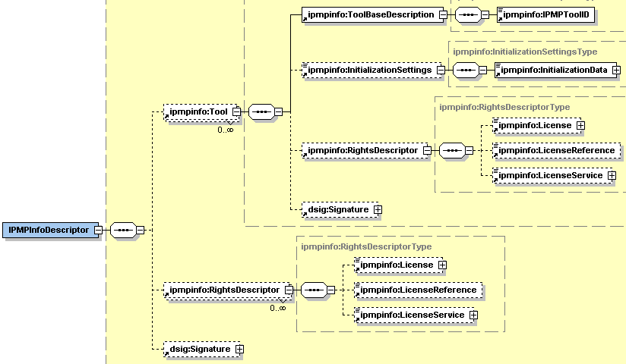

Figure 1. IPMPInfoDescriptor element from DMP

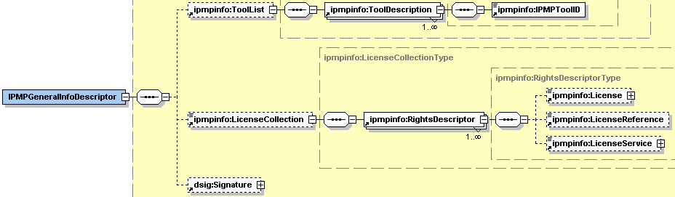

Figure 2. IPMPGeneralInfoDescriptor element from DMP

Main differences between MPEG-21 IPMP Components and DMP Profile are:
- RightsDescriptor element defined in DMP profile doesn’t provide the way to specify the IPMP tool information to unprotect the license if it is encrypted.
- DMP defines the KeyInfo element (see Figure 3) that is specified in XMLDSIG. This information is placed within the intilizationData element defined in the IPMPInfo schema. In MPEG-21 IPMP Components key information is not considered.
- DMP Profile does not specify the mechanism to protect a resource partially
- DMP Profile does not specify mechanisms to update IPMP Tools

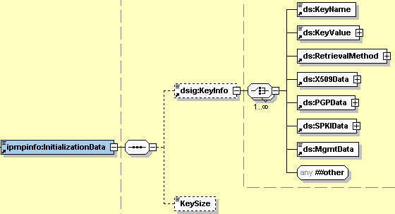

Figure 3. InitializationData element

Governed elements

Content is governed in the same way in DMP and in MPEG-21 standard. In the MPEG-21 standard if a DI or parts thereof or an asset can be governed using the appropriate mechanisms defined in the MPEG-21 IPMP Components standard specification, a license can be associated with the target of their governance using the RightsDescriptor element.
In the same way in DMP, if any Content Data Element within a Content Item is governed, its governance is expressed in the DMP Content Information (DCI) according to a DMP profile of the MPEG-21 IPMP Components Standard (see figures 1 and 2). For every Governed Resource part of the Content Item, an IPMPInfoDescriptor element shall appear in the appropriate location within the DCI.

Location of licenses in the Content

Every Governed Content Data Element needs a License to be used. MPEG-21 and DMP use the same mechanisms to govern objects. DMP specification provides placeholders for Licenses and/or references to them. The presence of a License shall be signalled in the DCI in the LicenseCollection element, which is child of IPMPGeneralInfoDescriptor element. Entries in the LicenseCollection are references to Licenses, which can be:
- Part of the DCI and contained in the IPMPGeneralInfoDescriptor;
- Part of the DCI and contained in the IPMPInfoDescriptor associated to the Governed Resource;
- Part of the DMP Content Format (DCF) and therefore contained in the License_Container Box described in the “PackageContent” section;
- Available from a LicenseService, and in this case the URL of the Service is given.

During the meeting it has been suggested to AXMEDIS of putting the AXInfo into a unique Descriptor to have the possibility of manipulate it a unique chunk of information. This is also reasonable for streaming…

Relationship between DMP Profile of MPEG-21 IPMP Components and AXMEDIS and MPEG-21 IPMP itself

In the previous section the comparison of description capabilities of DMP profile of MPEG-21 IPMP and MPEG-21 IPMP itself has been made. In this section, we are going to point out the features which will be implemented in AXMEDIS protection system and which are in contrast with DMP profile.

Point 1)
We are convinced that partial protection of resources (protection of subsets of resources included) is a key point for protection efficiency and for the B2B evolution of the digital market. Therefore, this feature will be supported by AXMEDIS. This implies that only AXMEDIS Object containing wholly protected resources can be transformed in a DMP-compliant digital item.

Point 2)
Another key point for AXMEDIS, which is not considered in DMP profile, is the capabilities to use different types of protection tools. In fact, DMP imposes as unique child elements of the ipmpinfo:InizializationData the dsig:KeyInfo and KeySize elements. Obviously, that choice implies that only protection tools which need this kind of initialization settings can be used by DMP-compliant device. On the contrary, AXMEDIS requires being able to use several kind of tools, such as: encryption, scramble, compression, etc.

About specification of update mechanism for IPMP tools, we would like to point out that AXMEDIS features can be easily augmented to provide support to update description even if currently no protection tool distribution/update server are not considered in the AXMEDIS architecture.

The above statement marked in pink is not clear to me (Paolo Nesi).
Remark:
These are the main differences between DMP requirements and AXMEDIS’s. It can be noticed that an AXMEDIS Object can be transformed in a DMP-compliant one forcing some restrictions to the AXMEDIS protection model.

It seems that any Protected DMP object can be transformed into a protected AXMEDIS object, while not all the AXMEDIS objects may become Protected DMP objects respecting all the enforced rules of AXMEDIS.

Relationship among MPEG-21 REL, DMP Profiles of MPEG-21 REL and AXMEDIS

In this section, MPEG-21 REL, DMP profile of MPEG-21 REL and the MPEG-21 REL implementation specified for AXMEDIS are compared.
We also compare the DMP profile of MPEG-21 REL with the mobile profiles for MPEG-21 REL defined in MPEG-21 standard, as the DMP profile is for Portable Audio and Video (PAV) devices. MPEG-21 REL mobile profiles are:
- MPEG-21 mobile profile based on the first requirements specified by the OMA (MPEG-21 REL MP1).
- MPEG-21 mobile profile based on OMA DRM v2 specification (MPEG-21 REL Mobile profile MP2).

MPEG-21 REL Core
MPEG-21 REL Core schema provides normative technical details regarding the core of the MPEG-21 REL design and architecture.
Figure 4 shows the DMP profile of MPEG-21 REL core.

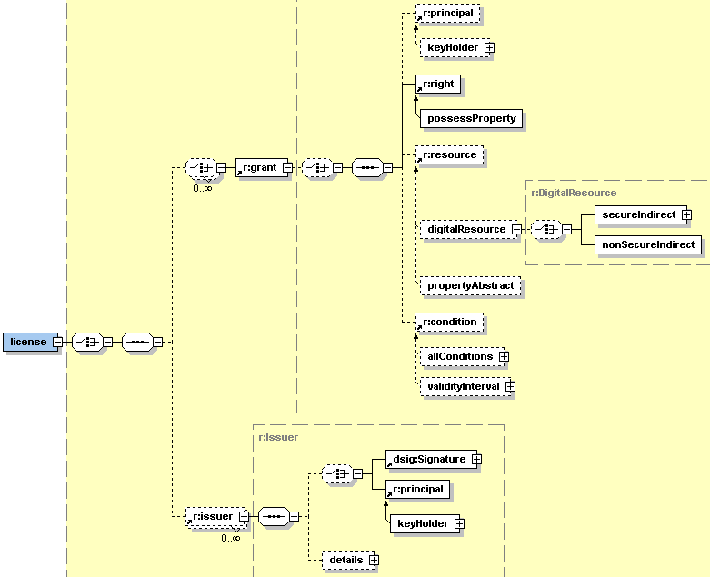

Figure 4. DMP profile for MPEG-21 REL core
DMP profile and MPEG-21 REL MP1 comparison:
- MPEG-21 REL MP1 considers the elements forAll, anXmlPatternAbstract, anXmlExpression, resourcePatternAbstract and principalPatternAbstract, which the DMP profile doesn’t consider.

DMP profile and MPEG-21 REL MP2 comparison:
- MPEG-21 REL MP2 doesn’t consider the elements: possessProperty right and propertyAbstract resource.
- MPEG-21 REL MP2 considers the otherInfo element to place version and uid elements, which the DMP profile doesn’t consider.

In AXMEDIS all the elements considered by the DMP profile of MPEG-21 REL and MPEG-21 REL MP1 and MP2 are considered.

MPEG-21 REL standard extension
MPEG-21 REL standard extension schema defines types and elements common to many MPEG-21 REL usage scenarios but which do not form part of the core language.
DMP profile for MPEG-21 REL standard extension considers the following elements:
- Conditions
  - exerciseLimit
  - validityIntervalFloating
  - validityTimeMetered
- Resource
  - propertyURI

There are no differences between DMP profile and MPEG-21 REL MP1.

DMP profile and MPEG-21 REL MP2 comparison:
- DMP profile and MPEG-21 REL MP2 consider the conditions exerciseLimit, and validityTimeMetered.
- MPEG-21 REL MP2 considers the condition validityIntervalDurationPattern instead of validityIntervalFloating
- MPEG-21 REL MP2 does not consider propertyURI element.

Main differences among AXMEDIS, MPEG-21 REL and DMP are:
- AXMEDIS considers all the rights defined in DMP profile for MPEG-21 REL standard extension
- Currently, the resource propertyURI is not considered in AXMEDIS, but it could be included if necessary.

NOTE: In AXMEDIS, groups and domains will be managed in different ways, for example licenses will be provided to each one of the members of a domain. For this case, we will extend the license model to support this functionally in the same way as MPEG-21 REL does. Then, we will consider the possessProperty right, all kind of resources that its substitutionGroup is r:propertyAbstract (for example the element sx:propertyURI) and the prerequisiteRight condition.
Response to the Note from Nesi: The fact that the license is managed by all the members of the domain permits at the devices belonging to a demain to manage the lack of connectivity. This seems to be ignored or not mentioned in DMP.

MPEG-21 REL multimedia extension

The MPEG-21 REL Multimedia Extension expands the Core Schema by specifying terms that relate to digital works. Specifically describes rights, conditions and metadata for digital works.
DMP profile for MPEG-21 REL multimedia extension only considers the following elements defined as rights in the MPEG-21 REL multimedia extension:
- play
- print
- move

DMP profile and MPEG-21 REL MP1 comparison:
- MPEG-21 REL MP1 considers the rights play and print, as the DMP profile
- MPEG-21 REL MP1 considers the right execute and the DMP profile the rights move.

DMP profile and MPEG-21 REL MP2 comparison:
- MPEG-21 REL MP2 considers the rights (play, print and move) as the DMP profile
- MPEG-21 REL MP2 also considers execute and adapt with prohibitedAttributeChanges (instead of copy) rights and the renderer element.

AXMEDIS considers all the rights defined in DMP profile for MPEG-21 REL multimedia extension and MPEG-21 REL MP1 and MP2.

DMP Represent Rights Expressions Schema

DMP Represent Rights Expressions Schema defines the following elements:
- Rights
  - copy
  - store
- Resource
  - ProtectedResource (see Figure 5)

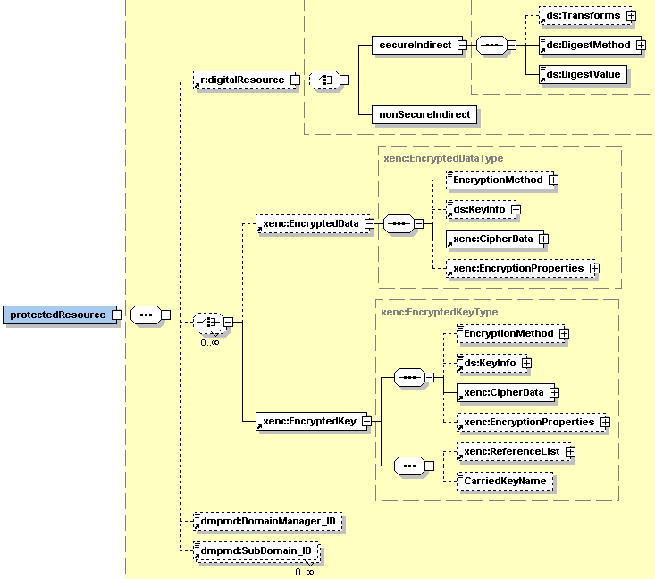

Figure 5. protectedResource element

DMP profile and MPEG-21 REL MP1 comparison:
- MPEG-21 REL MP1 defines the rights moveToDRMS and copyToDRMS instead of store and copy
- Both define the protectedResource element

DMP profile and MPEG-21 REL MP2 comparison:
- MPEG-21 REL MP2 uses the right adapt with prohibitedAttributeChanges instead of copy
- MPEG-21 REL MP2 does not define the protectedResource element

The elements defined in the DMP Represent Rights Expressions extension of MPEG-21 REL (protectedResource, copy and store) are not defined in AXMEDIS. Currently, AXMEDIS does not define any extension of MPEG-21 REL. We have to consider if the protectedResource element is necessary in a license (with the protection information and keys) or if we consider that this information will be defined and associated to an asset using MPEG-21 IPMP Components specification.
Note from Nesi: it seems to be very relevant to managed DMP governed objects. In addition, this change seems to have a quite limited impact in all the rest of the architecture. In addition, it seems to be key or concept to open the path to formalize a series of other behaviours on terminal related to Copy, Move, migrate, lend, etc.

Annex I - Identification of content, licenses, devices and domains in DMP

In order to give a hint for its implementation in AXMEDIS, this section presents how DMP specifies the identification of content, licenses and domains based on MPEG-21 DII.

The differences with AXMEDIS have to be reported yet…..

DMP Profile of MPEG-21 DII Schema defines two elements:
- Identifier
- RelatedIdentifier

Content identification

urn:{a urn namespace for dmp}:{a subordinate namespace}:{subordinate-specific Content Identifier}
or
urn:{a urn namespace for 3rd party}:{namespace-specific Content Identifier}

License identification
License identification is performed as content identification, as a license can be represented as a DCI.

Device identification
Device identifier is mainly used for device authentication. There can be two kinds of device identification:
- Device info-based identification: the identifier is generated only based on the device information by the device identification server run by the Registration Agency. Figure below shows the identifier format of device info based identification.

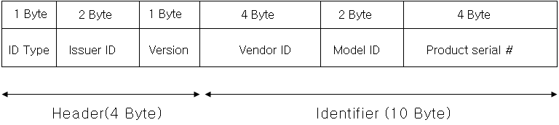

- Certificate-based identification: in which a X.509 certificate is utilized for device identifier. Figure below shows the identifier format for the certificate-based identification.

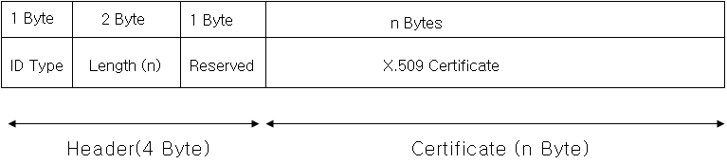

In AXMEDIS
In AXMEDIS there are three types of Device identification:
- the ID, stored in both client and AXCS, visible to all.
- the Certificate, produced by the AXCS and sent to the Device, etc….used for communication, etc..
- the Fingerprint, estimated at run time, stored into the AXCS: Stored during registration comprised of several parts, very precise and innovative technology and protocol.

Domain identification

Domain → group of devices.
The allocation of Domain Identifiers is carried out by Domain Registration Agencies, which are appointed by the Domain Registration Authority.
The format of the Domain ID is:
<element name = "Domain_ID " type = "r:Keyholder"/>

As a Domain is typically utilised by a group of Users it is often beneficial to be able to Identify sub-Domains within a given Domain, where each sub-Domain corresponds to a member of the group. The creation of a sub-Domain is achieved in the same way as the original Domain was established, this time generating a sub-Domain ID. The sub-Domain ID can be included in a Content License as representing the target of the Content in the same way as the Domain or Device ID. Multiple sub-Domains may appear within a Content License. Format of Sub-Domain ID is:
<element name="SubDomain_ID" type="anyURI"/>

Meeting of 14/05/2005

At the meeting: P. Nesi. L. Chiariglione, F. Chiariglione, P. Bellini, A. Vallotti, I. Bruno

Questions and Answers

- The DMP has specified the architectures for some distribution cases, and it is going to standardize some protocols and formats behind these architectures and solutions to business problems. Thus, in this process it has issued some calls for technologies/tools and companies have proposed solutions. How it work after?
  - Companies are proposing solutions that have to be accepted by DMP to become standards. The acceptance depends on the discussion and the acceptance of other DMP partners and people attending meetings such as in MPEG.
  - The details that are missing in the DMP specification of architecture are included in the proposed solutions that will converge to the final solution according to the mechanism of proposal and acceptance sch as in MPEG. In any case, the solution is going to cover those details in SW and Document. As in MPEG the Standard includes both the document and the reference software, they are not separable. This means that to answer at a DMP call implies as a sort of commitment to provide reference software that demonstrates the core part (give the evidence) of the solution. The full software or the software solving completely the problem with higher performance and GUI can be keep for the commercial business. On this line in AXMEDIS a decision has to be taken regarding the position of AXMEDIS.
  - ADETTI is a consortium that is presently hosting the reference software for DMP in CVS
- Access to information.
  - We have proposed to have a reciprocal affiliation from AXMEDIS and DMP or a liaison. They are not the same thing. In effect, we can have a liaison which is not a reciprocal affiliation with all subscribers of DMP. This means that we can give access to some AXMEDIS documents to DMP experts on demand but not the access to the CVS repository, etc. The same may happen for them. This has to be discussed depending on our aim…..
  - In alternative some partners can become affiliated with DMP and some of DMP partners may become AXMEDIS affiliated partners….
- DMP aim
  - Phase I: DMP is mainly focussed on mobile terminal and related business for audio visual
  - Phase II: DMP is moving on Pay TV and IPTV.
  - Phase III: could be on content production and improving what has been defined in previous phases…
- Streaming
  - The idea is to stream MPEG-21 objects as MPEG2 segments….
  - On IP-TV the streaming has been suggested to be performed by using the mechanisms of digital radio, with buffering, etc.

Mantioned Next DMP Meetings:
- 27-28-29 Close to Turin for requirements of the DMP call III phase of July
- Erlanghen ??, Germany the week before the MPEG Poznan Meeting, production of the DMP call III

AXMEDIS Actions

- Include L. Chiariglione and F. Chiariglione in the AXMEDIS User Group (UNIVLEEDS)
- Invite them at the next User Group AXMEDIS Meeting in September 2005 (UNIVLEEDS)
- Revise this document ..(DSI, DONE)

