




AXMEDIS

Automating Production of Cross Media Content
for Multi-channel Distribution
www.AXMEDIS.org

AXMEDIS Visual and Behavioural Editor
so called the internal SMIL Editor
User Guide

Version: 0.0.1
Date: 12/02/2007
Responsible: EPFL

Project Number: IST-2-511299
Project Title: AXMEDIS
Deliverable Type: Public
Visible to User Groups: Yes
Visible to Affiliated: Yes
Visible to Public: Yes

Deliverable Number: 0.0.1
Contractual Date of Delivery:
Actual Date of Delivery:
Work-Package contributing to the Deliverable:
Task contributing to the Deliverable:
Nature of the Deliverable: prototype
Author(s): EPFL

Abstract:
This document is a user guide for the SMIL internal Editor of AxEditor

Keyword List:
AXMEDIS FRAMEWORK, PLUG-IN, MULTIMEDIA, ADAPTATION

Document responsible
name: Samuel Kelelr
Email address: samuel.keller@epfl.ch
Affiliation acronym: EPFL

Schedule:
- Date <…..>:
work to be done
- Date <…..>:
work to be done
- Date <…..>:
work to be done
- Finale Deadline Date <…..>:
work to be done

Telephone Call with the document responsible
Telephone number with area code:……………
Time slot for telephone talking:
- <week day>, <start time> to <end time> : NUMBER IF DIFFRERENT FROM ABOVE
- <week day>, <start time> to <end time> : NUMBER IF DIFFRERENT FROM ABOVE

Telephone Conference with more people
Telephone number with area code:……………
Time slot for telephone talking:
- <week day>, <start time> to <end time> : NUMBER IF DIFFRERENT FROM ABOVE
- <week day>, <start time> to <end time> : NUMBER IF DIFFRERENT FROM ABOVE

Video Conference with the document responsible
Computer IP for the call:
Tools needed or suggested:……….type and version……..
Details about the configuration (if needed):….…resolution, etc…..
Time slot if they are different than those above:
- <week day>, <start time> to <end time>
- <week day>, <start time> to <end time>

Notes
The <start time> and <end time> indicate the temporal window in which the talk can start and not the maximum duration of the conference meeting.

AXMEDIS Copyright Notice
The following terms (including future possible amendments) set out the rights and obligations licensee will be requested to accept on entering into possession of any official AXMEDIS document either by downloading it from the web site or by any other means.
Any relevant AXMEDIS document includes this license. PLEASE READ THE FOLLOWING TERMS CAREFULLY AS THEY HAVE TO BE ACCEPTED PRIOR TO READING/USE OF THE DOCUMENT.
- DEFINITIONS
    - "Acceptance Date" is the date on which these terms and conditions for entering into possession of the document have been accepted.
    - "Copyright" stands for any content, document or portion of it that is covered by the copyright disclaimer in a Document.
    - "Licensor" is AXMEDIS Consortium as a de-facto consortium of the EC project and any of its derivations in terms of companies and/or associations, see www.axmedis.org
    - "Document" means the information contained in any electronic file, which has been published by the Licensor’s as AXMEDIS official document and listed in the web site mentioned above or available by any other means.
    - "Works" means any works created by the licensee, which reproduce a Document or any of its part.
- LICENCE
  - The Licensor grants a non-exclusive royalty free licence to reproduce and use the Documents subject to present terms and conditions (the Licence) for the parts that are own and proprietary property the of AXMEDIS consortium or its members.
  - In consideration of the Licensor granting the Licence, licensee agrees to adhere to the following terms and conditions.
- TERM AND TERMINATION
  - Granted Licence shall commence on Acceptance Date.
  - Granted Licence will terminate automatically if licensee fails to comply with any of the terms and conditions of this Licence.
  - Termination of this Licence does not affect either party’s accrued rights and obligations as at the date of termination.
  - Upon termination of this Licence for whatever reason, licensee shall cease to make any use of the accessed Copyright.
  - All provisions of this Licence, which are necessary for the interpretation or enforcement of a party’s rights or obligations, shall survive termination of this Licence and shall continue in full force and effect.
  - Notwithstanding License termination, confidentiality clauses related to any content, document or part of it as stated in the document itself will remain in force for a period of 5 years after license issue date or the period stated in the document whichever is the longer.
- USE
  - Licensee shall not breach or denigrate the integrity of the Copyright Notice and in particular shall not:
    - remove this Copyright Notice on a Document or any of its reproduction in any form in which those may be achieved;
    - change or remove the title of a Document;
    - use all or any part of a Document as part of a specification or standard not emanating from the Licensor without the prior written consent of the Licensor; or
    - do or permit others to do any act or omission in relation to a Document which is contrary to the rights and obligations as stated in the present license and agreed with the Licensor
- COPYRIGHT NOTICES
  - All Works shall bear a clear notice asserting the Licensor’s Copyright. The notice shall use the wording employed by the Licensor in its own copyright notice unless the Licensor otherwise instructs licensees.
- WARRANTY
  - The Licensor warrants the licensee that the present licence is issued on the basis of full Copyright ownership or re-licensing agreements granting the Licensor full licensing and enforcement power.
  - For the avoidance of doubt the licensee should be aware that although the Copyright in the documents is given under warranty this warranty does not extend to the content of any document which may contain references or specifications or technologies that are covered by patents (also of third parties) or that refer to other standards. AXMEDIS is not responsible and does not guarantee that the information contained in the document is fully proprietary of AXMEDIS consortium and/or partners.
  - Licensee hereby undertakes to the Licensor that he will, without prejudice to any other right of action which the Licensor may have, at all times keep the Licensor fully and effectively indemnified against all and any liability (which liability shall include, without limitation, all losses, costs, claims, expenses, demands, actions, damages, legal and other professional fees and expenses on a full indemnity basis) which the Licensor may suffer or incur as a result of, or by reason of, any breach or non-fulfilment of any of his obligations in respect of this Licence.
- INFRINGEMENT
  - Licensee undertakes to notify promptly the Licensor of any threatened or actual infringement of the Copyright which comes to licensee notice and shall, at the Licensor’s request and expense, do all such things as are reasonably necessary to defend and enforce the Licensor’s rights in the Copyright.
- GOVERNING LAW AND JURISDICTION
  - This Licence shall be subject to, and construed and interpreted in accordance with Italian law.
  - The parties irrevocably submit to the exclusive jurisdiction of the Italian Courts.

Please note that:
- You can become affiliated with AXMEDIS. This will give you the access to a huge amount of knowledge, information and source code related to the AXMEDIS Framework. If you are interested please contact P. Nesi at nesi@dsi.unifi.it. Once affiliated with AXMEDIS you will have the possibility of using the AXMEDIS specification and technology for your business.
- You can contribute to the improvement of AXMEDIS documents and specification by sending the contribution to P. Nesi at nesi@dsi.unifi.it
- You can attend AXMEDIS meetings that are open to public, for additional information see WWW.axmedis.org or contact P. Nesi at nesi@dsi.unifi.it
Table of Contents

1 Executive Summary and Report Scope (mandatory) 7
2 Introduction (mandatory) 7
3 General Commands 7
3.1 SMIL resource combo box 8
3.2 New SMIL 8
3.3 Open SMIL 9
3.4 Save SMIL 10
3.5 Save SMIL As 10
4 Tree view part 10
4.1 SMIL 11
4.1.1 Add Metas 12
4.1.2 Add Transitions 13
4.2 Meta 14
4.2.1 Rename 14
4.2.2 Modify 15
4.2.3 Delete 15
4.3 Transition 16
4.3.1 Rename 16
4.3.2 Modify 17
4.3.3 Delete 17
4.4 Rootlayout 18
4.4.1 Modify 19
4.4.2 Add region 19
4.5 Region 21
4.5.1 Rename 22
4.5.2 Modify 23
4.5.3 Delete 24
4.5.4 Add Region 25
4.5.5 Show Medias 25
4.6 Body 26
4.6.1 Add Container 26
4.6.2 Add Medias 27
4.7 Common timing operations 28
4.7.1 Move Up 28
4.7.2 Move Down 29
4.7.3 Rename 29
4.8 Containers 29
4.8.1 Add Container 29
4.8.2 Add Medias 30
4.8.3 Modify 31
4.8.4 Delete 32
4.9 Medias 32
4.9.1 Add Link 33
4.9.2 Select Region 34
4.9.3 Modify 34
4.9.4 Delete 35
4.10 Links 36
4.10.1 Modify 36
4.10.2 Rename 37
4.10.3 Delete 37
5 Visual view part 37
5.1 Root-layout Editing 38
5.1.1 Modify 39
5.1.2 Add region 40
5.2 Region Editing 41
5.2.1 Modify 41
5.2.2 Delete 42
5.2.3 Add Region 43
5.2.4 Show Medias 44
6 Behaviour view part 44
6.1 Description of components 45
6.2 Time Ruler and Zoom 46
6.3 Timings 46
6.3.1 Main Sequence 47
6.3.1.1 Add Container 47
6.3.1.2 Add Medias 48
6.3.2 Common Timing operations 49
6.3.2.1 Move Up 50
6.3.2.2 Move Down 50
6.3.2.3 Undefine Duration 50
6.3.2.4 Mouse modifications 50
6.3.3 Containers 51
6.3.3.1 Add Container 51
6.3.3.2 Add Medias 52
6.3.3.3 Modify 53
6.3.3.4 Delete 54
6.3.4 Medias 55
6.3.4.1 Add Link 55
6.3.4.2 Select Region 56
6.3.4.3 Modify 56
6.3.4.4 Delete 57
7 Example 58
7.1 Introduction 58
7.2 Basic Files 58
7.3 Create the SMIL 58
7.4 Edit SMIL 59
7.4.1 Modify Root Layout 59
7.4.2 Add Regions 61
7.4.3 Timing 65
7.4.3.1 Containers 65
7.4.3.2 Medias 66
7.4.3.3 CreatingTransitions 68
7.4.3.4 Setting timing 69
7.5 Saving SMIL 72

Executive Summary and Report Scope (mandatory)

This document is a user guide for the SMIL internal Editor of AxEditor.

Introduction (mandatory)

The SMIL Editor allows editing of SMIL resources from the AxEditor by a visual interface. It is divided in three parts: the tree view part that shows the whole SMIL structure, the visual part that shows the regions used for resources displaying and the behaviour part that shows the timing structure and properties.

General Commands

You can use the functions from the Axmedis Editor to create a new SMIL resource, open an existing SMIL resource, save a SMIL resource, and save a SMIL resource as another SMIL resource as follows:

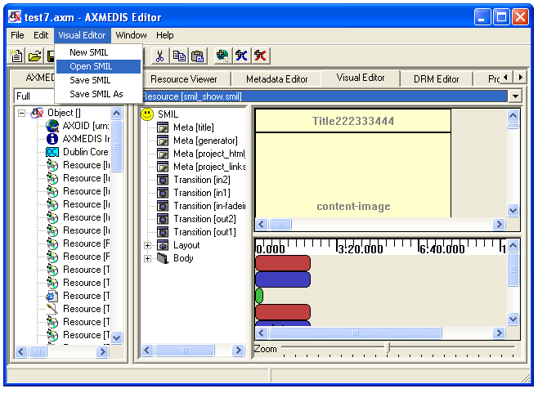

SMIL resource combo box
You can use this function to select the SMIL resources embedded inside the axmedis object as follows. 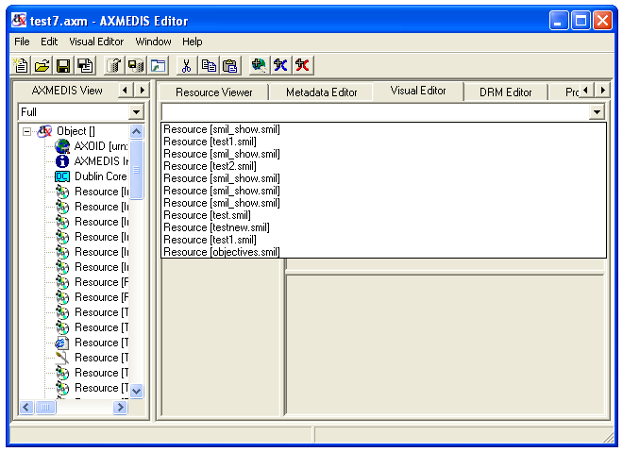

New SMIL
3.2.1 When you have no SMIL resource loaded and select the option of “New SMIL”, the SMIL editor will create a very simple SMIL resource with only rootlayout and body container as follows:
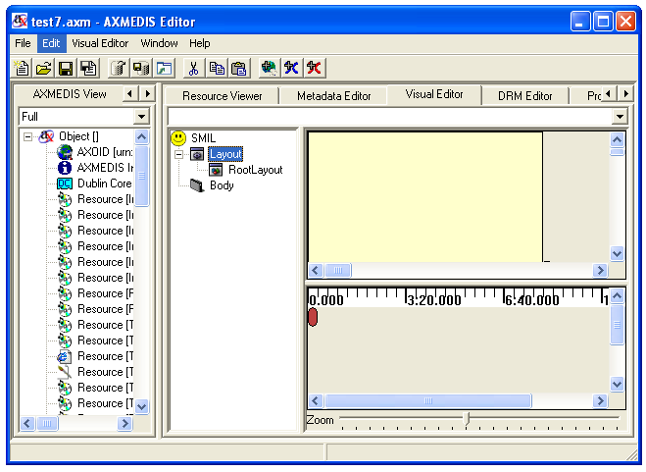

3.2.2 When you have a SMIL resource loaded and select the option of “New SMIL”, the SMIL editor will first ask you if you want to save the current resource or not and then create a very simple SMIL resource with only rootlayout and body container as section 3.2.1:
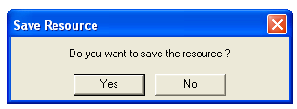

Open SMIL
3.3.1 When you have no SMIL resource loaded and select the option of “Open SMIL”, the SMIL editor will pop up a dialog for you to select the SMIL resources embedded inside the axmedis object as follows:

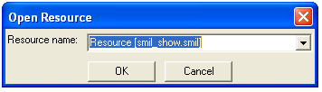

3.3.2 When you have a SMIL resource loaded and select the option of “Open SMIL”, the SMIL editor will first pop up a dialog to ask you if you want to save the current resource or not and then pop up a dialog for you to select the SMIL resources embedded inside the axmedis object as section 3.3.1:

Save SMIL

3.4.1 When you have no SMIL resource loaded and select the option of “Save SMIL”, the SMIL editor will pop up a dialog for you to save the SMIL resources as a new resource embedded inside the axmedis object as follows:
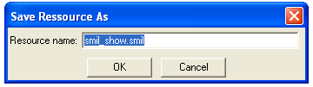

3.4.2 When you have a SMIL resource loaded and select the option of “Save SMIL”, there will pop up a dialog asking you if you want to overwrite the current one or not.

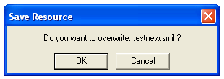

Save SMIL As
When you have a SMIL resource loaded and select the option of “Save SMIL As”, there will pop up a dialog for you to save this resource as another resource.

Tree view part

The tree part is located at the left of the SMIL Editor.

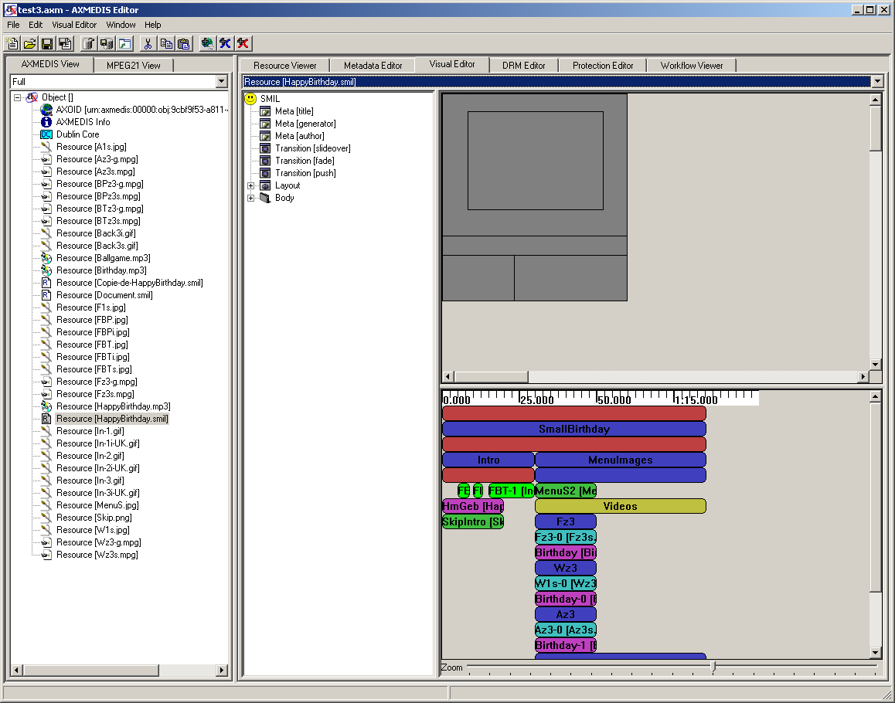

The tree view part of the SMIL editor is used for manipulating the whole SMIL with his internal structure. It is the only view that can display/edit completely Metas, Transitions and Links.

SMIL

You can add Metas andTransitions to the SMIL by right clicking the SMIL icon as follows.

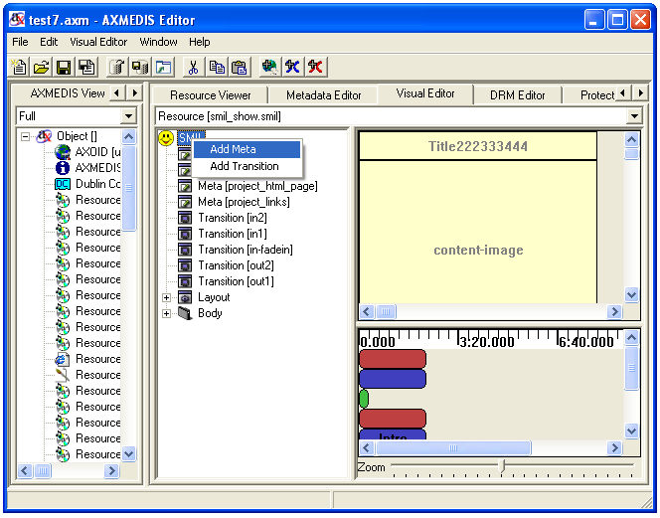

Add Metas

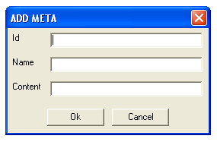

Id: ID of the meta. It uniquely identifies the Meta within this SMIL.

Name: Identifies a property name. It is required for Meta elements.
name | abstract | Gives the presentation abstract.
name | author | Lists the presentation author's name.
name | base | Sets the base URL for the source clips.
name | copyright | Supplies the presentation copyright.
name | title | Gives the presentation title.

Content: Provides the content for the name attribute..

Add Transitions

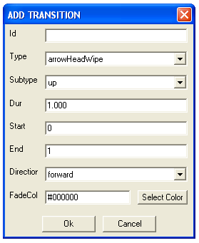

Id: ID of the transition (default: empty). It uniquely identifies the transition within this SMIL.

Type: Specifies the main transition type (default: none).

Subtype: Defines an optional subtype for each type.

Dur: Defines the length of the transition effect.

Start: Starts the effect at a midway point.

End: Ends the effect before it completes fully.

Direction: Specifies the transition direction (default value is forward).

FadeColor: Sets a color for fades.

You can choose the option of “Select Color” to customise the color. There will pop up the following dialog.

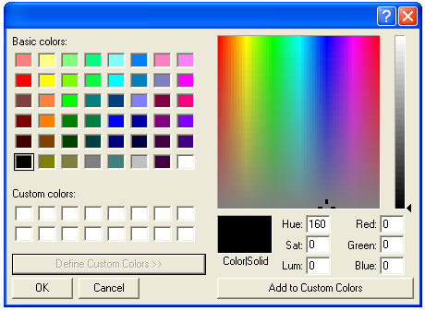

Meta

You can edit the Meta by right click the Meta. There would be three options: “Rename”, “Modify”, “Delete”
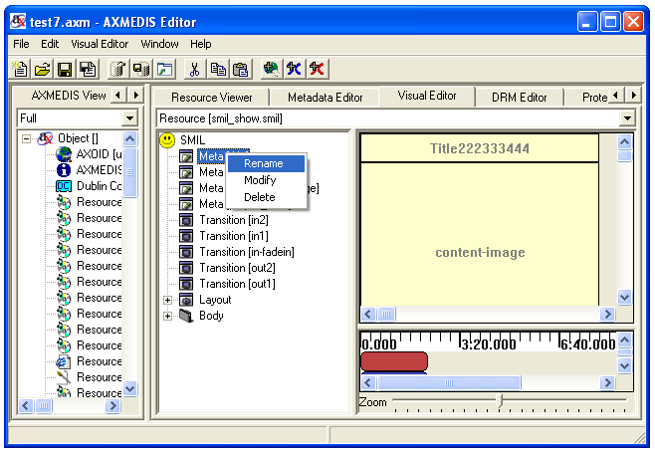

Rename

You can directly rename the Meta Name as the following.

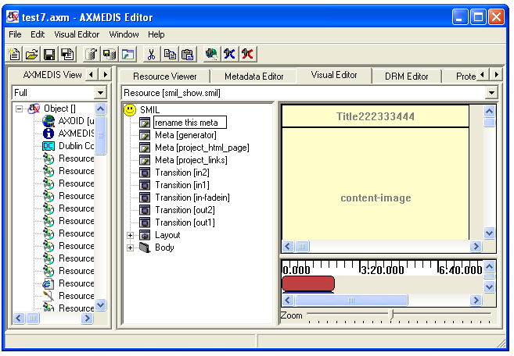

Modify

By choosing the option of “Modify”, you can modify the Meta with the following dialog:
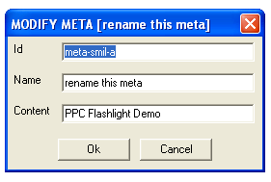
The attributes of this dialog are exactly the same as those of “Add Meta” described in 4.1.1.

Delete

By choosing the option of “Delete”, you can delete the Meta with the following dialog:
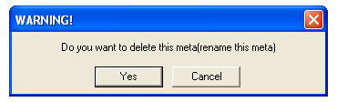

Transition

You can edit the transition by right click the transition. There would be three options: “Rename”, “Modify”, “Delete”.
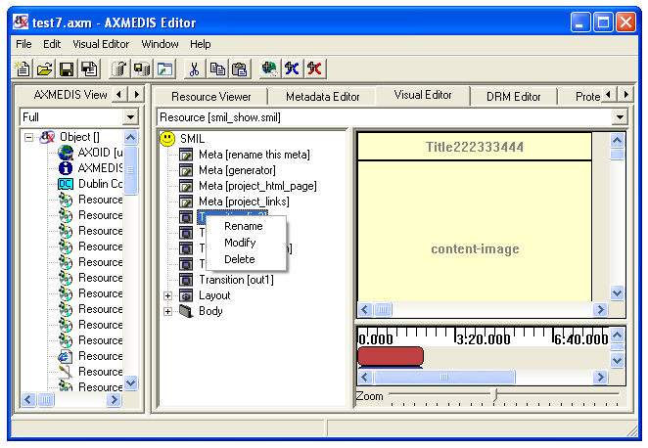

Rename

You can directly rename the transition name as the following:
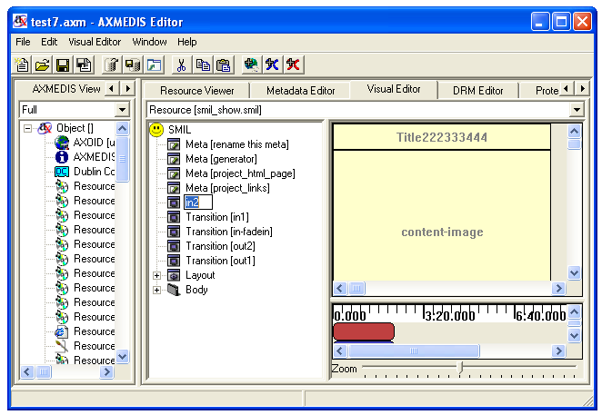

Modify

By choosing the option of “Modify”, you can modify the transition with the following dialog:

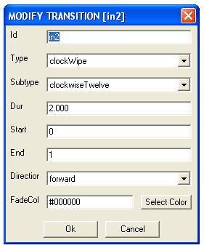

The attributes of this dialog are exactly the same as those of “Add transition” described in 4.1.2.

Delete

By choosing the option of “Delete”, you can delete the transition with the following dialog:

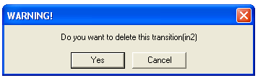

Rootlayout

You can modify the size of the root-layout by right clicking the root-layout element in the Tree View part (The same function as in the Visual View part). There will pop up a menu. One option is to modify the size and color of the root-layout. By inputting the values of the height and width, you can modify the size. With the dialog given, you can customize the color as well. The left top position is fixed at the left top corner of the canvas.

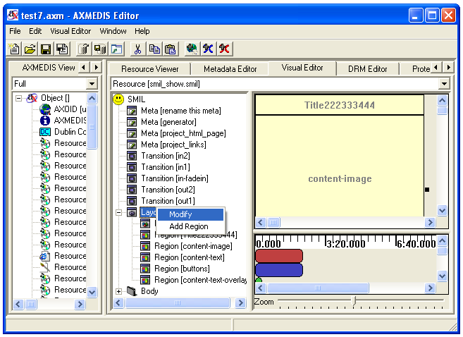

Modify
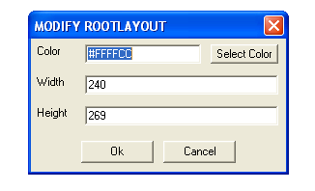
Color: Sets the window background color (default: black).

Width: Sets the main window width (default: 0).

Height: Sets the main window height (default: 0).

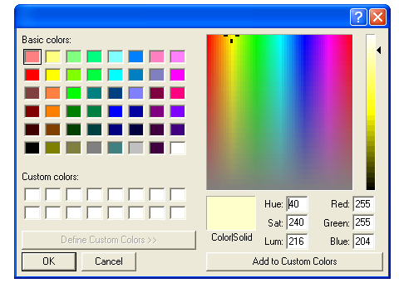

You can select the color by right-clicking the “Select Color” and there will pop up the color for choice.

Add region

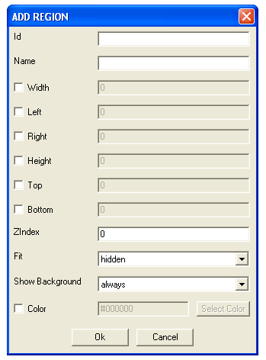
You can add the region into the root layout by selecting the option of “Add Region”.

Id: Uniquely identifies a region within the root-layout.

Name: Identified the region. It is not unique.

Width: Sets the region's width (default: auto).

Left: Sets the region's offset from the window's left side (default: auto).

Right: Sets the region's offset from the window's right side (default: auto).

Height: Sets the region's height (default: auto).
Top: Sets the region's offset from the top of the window (default: auto).
Bottom: Sets the region's offset from the bottom of the window (default: auto).
Z-Index: Sets the stacking order when the region overlaps another region (default: 0).
Fit: Controls how clips fit the region (default: hidden).

Show Background: Determines when the background color appears (default: always).

The governing equation for the horizontal dimension is: bbw (bounding-box-width) = left + width + right. Given that each of these three parameters can have either a value of "auto" or a defined value not "auto", then there are 8 possibilities:

Attribute values |  |  | Result before clipping to the bounding box
left | width | right | left | width | right
auto | auto | auto | 0 | bbw | 0
auto | auto | defined | 0 | bbw - right | right
auto | defined | auto | 0 | width | bbw - width
auto | defined | defined | bbw - right - width | width | right
defined | auto | auto | left | bbw - left | 0
defined | auto | defined | left | bbw - right - left | right
defined | defined | auto | left | width | bbw - left - width
defined | defined | defined | left | width | bbw - left - width

The vertical attributes height, bottom, and top are resolved similarly. The governing equation for the vertical dimension is: bbh (bounding-box-height) = top + height + bottom. Given that each of these three parameters can have either a value of "auto" or a defined value not "auto", then there are 8 possibilities:
Attribute values |  |  | Result before clipping to the bounding box
top | height | bottom | top | height | bottom
auto | auto | auto | 0 | bbh | 0
auto | auto | defined | 0 | bbh - bottom | bottom
auto | defined | auto | 0 | height | bbh - height
auto | defined | defined | bbh - bottom - height | height | bottom
defined | auto | auto | top | bbh - top | 0
defined | auto | defined | top | bbh - bottom - top | bottom
defined | defined | auto | top | height | bbh - top - height
defined | defined | defined | top | height | bbh - top - height

Region

You can modify the size of the region manually with dialog menu by right clicking the region element of the Tree View part (the same function of the Visual View part). There will pop up a menu. One option is to rename this region One option is to modify the size, position, index, and color of the region. One option is to delete this region. One option is add some sub-regions in side this region, one option is to show the media resources which are associated with this region. By inputting the values of the height and width, you can modify the size. With the dialog given, you can customize the color as well.
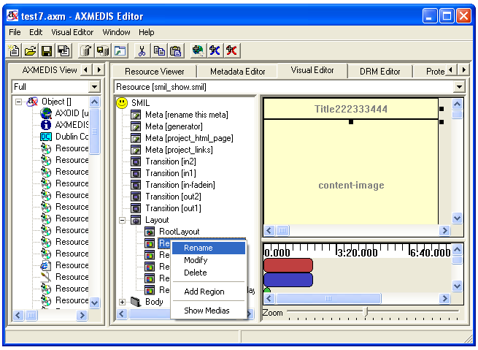

Rename

You can directly rename the region’s name as the following:

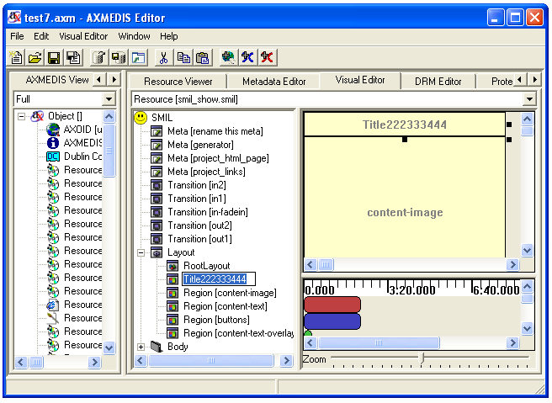

Modify

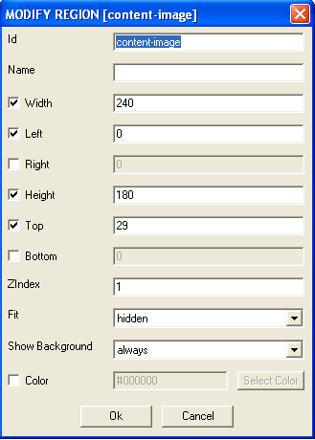

You can modify the region by choosing the option of “modify region”. There will pop up a dialog menu. The attributes are exactly the same as the part “add region” described in the root layout editing, section 4.4.2.

Delete

You can also delete the region by choosing the option of “delete”.

1) When there is no media resource associated with this region, there will popup the following warning dialog.
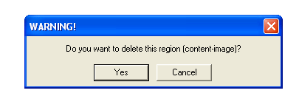

2) When there are some child regions associated with this region, there will popup the following warning dialog asking if you want to delete this region and all his children.

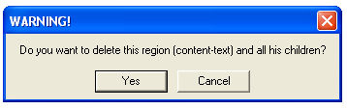

3) When there are some media resources associated with this region, there will popup the following warning dialog asking if you want to delete or change region for these resources. By option “Delete”, you can delete the region and the resources inside.
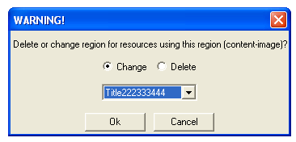

You can choose to use other regions to host these resources as follows. There will appear a list of all the other regions for changing.
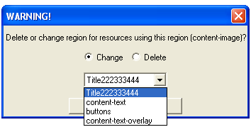

Add Region

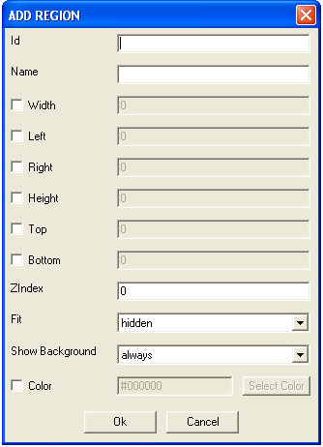

You can add new region by choosing the option of “Add Region”. There will pop up a dialog menu. The attributes of “Add Region” in region editing are exactly the same as the part “Add Region” described in the root layout editing, section 4.4.2.

Show Medias

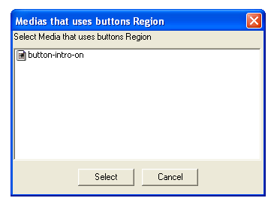

You can check which media is associated the region by choosing the option of “Show Medias”. You can select the Media from them for editing.

Body

The Body is also the main sequence and is a not modifiable sequence of timings. You can add Containers and Medias to it by right clicking on it and using the menu.

Add Container

To add a Container to the Body right click on it and select the submenu “Add Container” and choose the type of container you want to add.

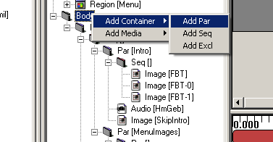

For example if you create a Par, a window like this will be displayed:

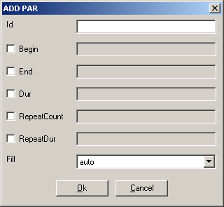

Now you can set the new Par properties and create it by clicking on “Ok”, you can also cancel the creation by clicking on “Cancel” or exiting the window. See section 3.1.3 for details about the Container.

Add Medias

To add a Media to the Body right click on it and select the submenu “Add Media” and choose the type of media you want to add.

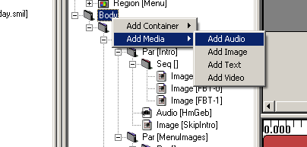

For example if you create an Audio, a window like this will be displayed:

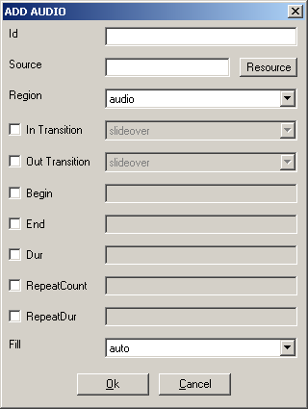

Now you can set the new Audio properties and create it by clicking on “Ok”, you can also cancel the creation by clicking on “Cancel” or exiting the window. See section 4.9.3 for details about the Medias properties.

Common timing operations

There are some common operations between Medias and Containers. You can see in the Menu the commands Move Up, Move Down and Rename are both in Media and Container Menus. Modify and delete are also common in the menus but loads different actions. (See sections 4.8 and 4.9)

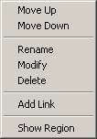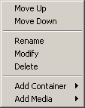

Move Up

The Move Up command can be loaded by right click on the Media/Container and selecting Move Up. It moves the timing selected up in the structure (in the order of his parent). It is disabled when the timing selected is at the top of his parent.

Move Down

The Move Down command can be loaded by right click on the Media/Container and selecting Move Down. It moves the timing selected down in the structure (in the order of his parent). It is disabled when the timing selected is at the bottom of his parent.

Rename

The Rename command can be loaded by right click on the Media/Container and selecting Rename. It opens the name editing. You can also open the editing by fast clicking on it.

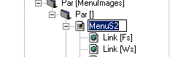

When you end the editing, the name is changed.

Containers

The Containers are the logical structure of the whole timing of the SMIL. You can add Containers and Medias to a Container by right clicking on it and using the menu. Containers could be Par, Seq or Excl for parallel, sequential and exclusive playing.

Add Container

To add a Container to a Container right click on it and select the submenu “Add Container” and choose the type of container you want to add.

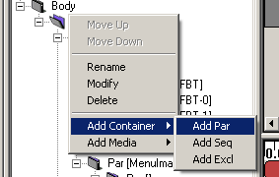

For example if you create a Par, a window like this will be displayed:

Now you can set the new Par properties and create it by clicking on “Ok”, you can also cancel the creation by clicking on “Cancel” or exiting the window. See section 3.1.3 for details about the Containers properties.

Add Medias

To add a Media to a Container right click on it and select the submenu “Add Media” and choose the type of media you want to add.

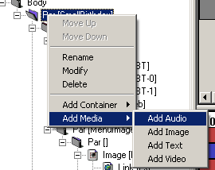

For example if you create an Audio, a window like this will be displayed:

Now you can set the new Audio properties and create it by clicking on “Ok”, you can also cancel the creation by clicking on “Cancel” or exiting the window. See section 4.9.3 for details about the Medias properties.

Modify

To modify by dialog a Container right click on it and select “Modify”. A window like this will be displayed.

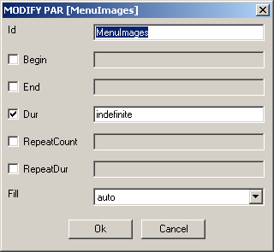

There you can set the following properties:

Id: ID of the container (default: empty)
The ID is used identify the Container in the SMIL

Begin: Begin of the container (default: not set)
The Begin set the start of the container; it is a list of beginnings. The general definition of W3C is supported:
http://www.w3.org/TR/SMIL2/smil-timing.html#adef-begin

End: End of the container (default: not set)
The End set the end of the container; it is a list of endings. The general definition of W3C is supported:
http://www.w3.org/TR/SMIL2/smil-timing.html#adef-end

Dur: Duration of the container (default: not set)
The Dur set the duration of the container; it is a single Duration value.

RepeatCount: Number of repetitions (default: not set)
The RepeatCount is used when you want to repeat the container a defined number of times.

RepeatDur: Duration of repetitions (default: not set)
The RepeatCount is used when you want to repeat the container for a defined duration.

Fill: Default Fill for Medias in this Container (default: auto)
The Fill is used to set default filling for Medias in the Container. It can have the following values: auto, remove, freeze, hold and transition.

Delete

To delete a Container right click on it and click on “Delete”. A confirms dialog will appear:
Like this one if the Container contains something.

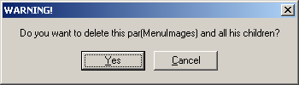

Like this one if not.
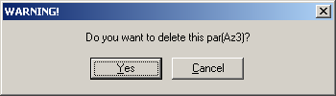

In both cases click Yes to delete the Container or Cancel or exit the window if you changed your mind.

Medias

The Medias are the resources played in the SMIL. You can add Link to a Media or select his Region by right clicking on it and using the menu. Medias could be Audio, Image, Text and Video for respective type of files playing.

Add Link

To add a Link to a Media right click on it and click the menu “Add Link”, a window like this will be displayed:

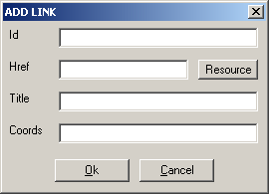

There you can set the following properties of the new Link:

Id: ID of the link (default: empty)
The ID is used identify the Link in the SMIL (used most of time for internal links).

Href: Link to load (default: empty)
The Href is used for external Links by setting a link to another SMIL file.

Title: Title of the Link(default: empty)
The Title is displayed as information when the SMIL is played.

Coords: Coordinates of the Link Region (default: empty= entire Region)
The Coords are a list of coordinates to define a sub-region mouse sensitive to load this link (the entire Region is used if it is not defined)

The Resource button allows setting the Href by selecting a SMIL resource in Axom. It loads a window like this:

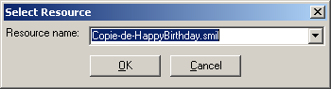

You simply select the resource you want to link and validate; the new Href will be set.

Select Region

To select the Region where a Media is played, simply right click on it and click the menu “Show Region”. The Region of the Media will be selected. (In Tree and Visual View)

Modify

To modify by dialog a Media right click on it and select “Modify”. A window like this will be displayed.

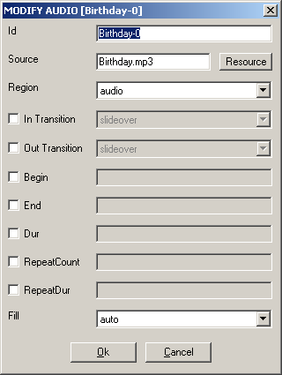

There you can set the following properties:

Id: ID of the Media (default: empty)
The ID is used identify the Media in the SMIL

Source: Source of the Media (default: empty)
The Source is used to link the resource played by this Media

Region: Region of the Media (default: first Region)
The Region defines the area where the Media will be played. You can select each region you have defined.

In Transition: Transition at start (default: not defined)
The In Transition defines the Transition at start where the Media will be played. You can select each Transition you have defined.

Out Transition: Transition at end (default: not defined)
The Out Transition defines the Transition at end where the Media will be played. You can select each Transition you have defined.

Begin: Begin of the Media (default: not set)
The Begin set the start of the Media; it is a list of beginnings. The general definition of W3C is supported:
http://www.w3.org/TR/SMIL2/smil-timing.html#adef-begin

End: End of the Media (default: not set)
The End set the end of the Media; it is a list of endings. The general definition of W3C is supported:
http://www.w3.org/TR/SMIL2/smil-timing.html#adef-end

Dur: Duration of the Media (default: not set)
The Dur set the duration of the Media; it is a single Duration value.

RepeatCount: Number of repetitions (default: not set)
The RepeatCount is used when you want to repeat the Media a defined number of times.

RepeatDur: Duration of repetitions (default: not set)
The RepeatCount is used when you want to repeat the Media for a defined duration.

Fill: Filling of the Media (default: auto)
The Fill is used to set the filling for the Media. It can have the following values: auto, remove, freeze, hold and transition.

The Resource button allows setting the Source by selecting a resource in Axom (selected by mime type). It loads a window like this:

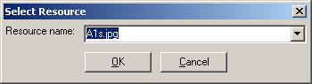

You simply select the resource you want to link and validate; the new Source will be set.

Delete

To delete a Media right click on it and click on “Delete”. A confirms dialog will appear:

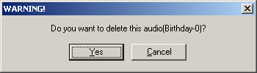

Click Yes to delete the Media or Cancel or exit the window if you changed your mind.

Links

The Links are the way to jump from a Media. They can be renamed, modified and deleted by menu.

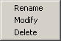

Modify

To add a Link to a Media right click on it and click the menu “Modify”, a window like this will be displayed:

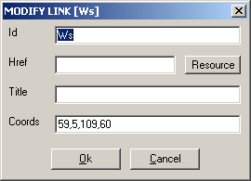

There you can set the following properties of the new Link:

Id: ID of the link (default: empty)
The ID is used identify the Link in the SMIL (used most of time for internal links).

Href: Link to load (default: empty)
The Href is used for external Links by setting a link to another SMIL file.

Title: Title of the Link (default: empty)
The Title is displayed as information when the SMIL is played.

Coords: Coordinates of the Link Region (default: empty= entire Region)
The Coords are a list of coordinates to define a sub-region mouse sensitive to load this link (the entire Region is used if it is not defined)

The Resource button allows setting the Href by selecting a SMIL resource in Axom. It loads a window like this:

You simply select the resource you want to link and validate; the new Href will be set.

Rename

The Rename command can be loaded by right click on the Link and selecting Rename. It opens the name editing. You can also open the editing by fast clicking on it.

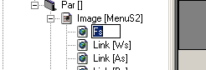

When you end the editing, the name is changed.

Delete

To delete a Link right click on it and click on “Delete”. A confirms dialog will appear:

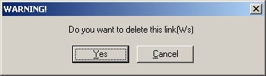

Click Yes to delete the Link or Cancel or exit the window if you changed your mind.

Visual view part

The visual part is located at the right top of the SMIL Editor.

The visual view part of the SMIL editor is used for manipulating the SMIL layout which including the Rootlayout, Regions, Sub-regions of regions.

Root-layout Editing

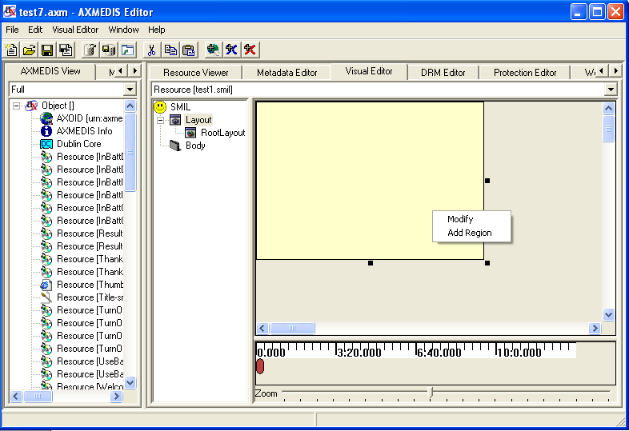

You can modify the size of the root-layout by using the mouse to change the size directly or manually with dialog menu by right clicking the root-layout. There will pop up a menu for you. One option is to modify the size and color of the root-layout. By inputting the values of the height and width, you can modify the size. With the dialog given, you can customize the color as well. The left top position is fixed at the left top corner of the canvas.

Modify
You modify the size and color of the root-layout by inputting the values of the height and width. See section 6.3.3.3 for more details about the properties.

You can select the color by right-clicking the “select color” and there will pop up the color for choice.

Add region

You can add the region into the root layout by selecting the option of “add region”. You can refer to section 6.3.3.32 for more details about the properties.

Region Editing

You can modify the size of the region by using the mouse to change the size directly or manually with dialog menu by right clicking the corresponding region. There will pop up a menu for you. One option is to modify the size, position, index, and color of the region. One option is to delete this region. One option is add some sub-regions in side this region, one option is to show the media resources which are associated with this region. By inputting the values of the height and width, you can modify the size. With the dialog given, you can customize the color as well.

By directly editing the region with mouse, you can move the region by holding the left key of the mouse and moving it. You can also drag the border of the region to resize it. The sub regions cannot exceed the borders of their parent regions. Also they cannot be moved out of the borders of their parent regions.
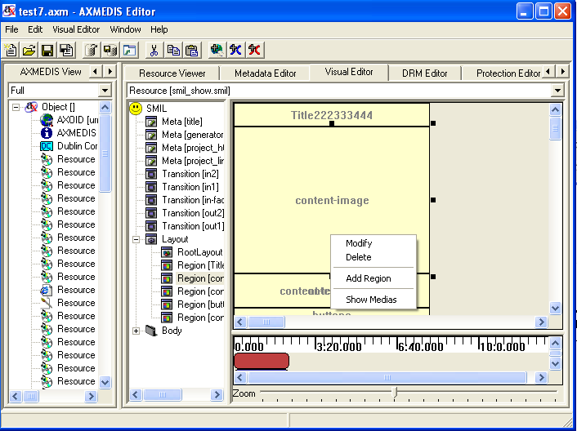

Modify

You can modify the region by choosing the option of “Modify”. There will pop up a dialog menu for you. You can refer to section 6.3.3.32 for more details about the properties.

Delete

You can also delete the region by choosing the option of “Delete”.

1) When there is no media resource associated with this region, there will popup the following warning dialog.

2) When there are some child regions associated with this region, there will popup the following warning dialog asking if you want to delete this region and all his children.

3) When there are some media resources associated with this region, there will popup the following warning dialog asking if you want to delete or change region for these resources. By option “Delete”, you can delete the region and the resources inside.

You can choose to use other regions to host these resources as follows. There will appear a list of all the other regions for changing.

Add Region

You can add new region by choosing the option of “add region”. There will pop up a dialog menu for you. The attributes of “add region” in region editing are exactly the same as the part “add region” described in the root layout editing.

Show Medias

You can check which media is associate the region by choosing the option of “Show Medias”. You can select the media from them for editing.

Behaviour view part

The behaviour part is located at the right bottom of the SMIL Editor.

Description of components

At the top of the behaviour view you can see the time ruler. This ruler gives timing information and a scaling view for the whole SMIL timing.
At the centre you can see and modify the timing attributes of the SMIL. At the top there is always an not modifiable anonym red bar that represent the main sequence who is the basic timing structure of the SMIL file. Under it, that means “in it”, you can add/modify/delete others containers like “Par” for parallel playing (all the contained together), “Seq” for Sequential playing (all the contained one after another) and “Excl” for Exclusion playing (only one of the contained upon a time). You can also add/modify/delete the medias that will be played.
If the timings are too big navigation scroll bars appears.
At the bottom, you can see and modify the zoom scale used for timing display.

Time Ruler Main Sequence Zoom

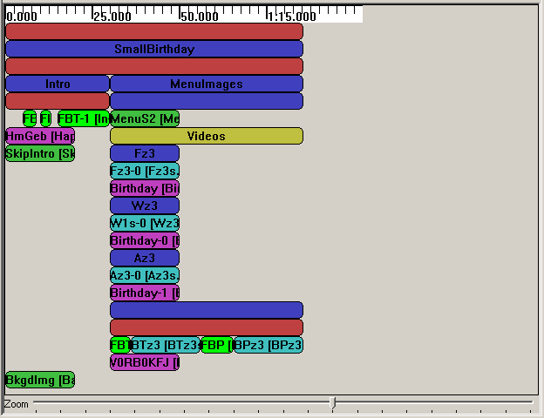

Time Ruler and Zoom

Time ruler and zoom show and allow seeing the global timing. One important thing to remember is that if durations are not defined for the whole SMIL file, the timing you will get in a player will be different from the one displayed because all not known durations are set by default to 20 seconds in the behaviour view. (see below for more details).

Timings

Timings are both Main Sequence and other Medias and Containers. (boxes in the middle). The meanings of the colours are:

Red: Sequence Container
Blue: Parallel Container
Yellow: Exclusive Container

Pink: Audio Media
Green: Image Media
Cyan: Video Media
White: Text Media

When a colour is shining the duration of the Media/Container is set.
When a colour is greyed the duration of the Media/Container is not set.

Main Sequence

The main sequence is a not modifiable sequence of timings. You can add Containers and Medias to it by right clicking on it and using the menu.

Add Container

To add a Container to the Main Sequence right click on it and select the submenu “Add Container” and choose the type of container you want to add.

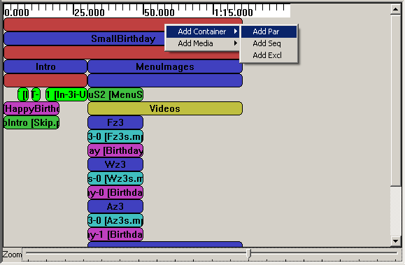

For example if you create a Par, a window like this will be displayed:

Now you can set the new Par properties and create it by clicking on “Ok”, you can also cancel the creation by clicking on “Cancel” or exiting the window. See section 6.3.3.3 for details about the Container.

Add Medias

To add a Media to the Main Sequence right click on it and select the submenu “Add Media” and choose the type of media you want to add.

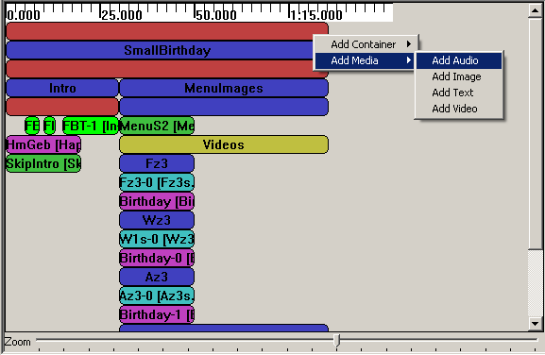

For example if you create an Audio, a window like this will be displayed:

Now you can set the new Audio properties and create it by clicking on “Ok”, you can also cancel the creation by clicking on “Cancel” or exiting the window. See section 6.3.4.3 for details about the Medias properties.

Common Timing operations

There are some common operations between Medias and Containers. You can see in the Menu the commands Move Up, Move Down and Undefine Duration are both in Media and Container Menus. Modify and delete are also common in the menus but loads different actions. (See sections 6.3.3 and 6.3.4)

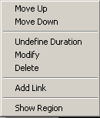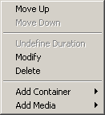

The mouse modifications are also in common.

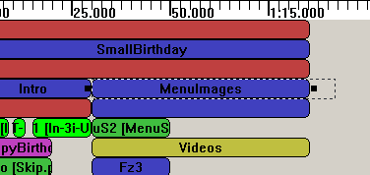

Move Up

The Move Up command can be loaded by right click on the Media/Container and selecting Move Up. It moves the timing selected up in the structure (in the order of his parent). It is disabled when the timing selected is at the top of his parent.

Move Down

The Move Down command can be loaded by right click on the Media/Container and selecting Move Down. It moves the timing selected down in the structure (in the order of his parent). It is disabled when the timing selected is at the bottom of his parent.

Undefine Duration

The Undefine Duration command can be loaded by right click on the Media/Container and selecting Undefine Duration. It removes a definition of Duration of the Timing (don’t remove them all). In order (when available) : Dur, Ends in the order of apparition.

Mouse modifications

The Begin, End and Duration attributes of timings can also be modified by mouse. To modify media/container, left click on it. If you keep the left down drag & drop is activated. The resource can only be moved horizontally. When the resource is dropped it takes the new time offset for begin.

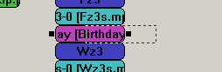

When the media/container are left clicked, a selection appears. When you drag and drop the black squares it changes durations and start (when using the left one).

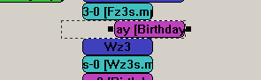

Please note that Seq doesn’t accept negative values, so the resource will be adjusted to be correct. Another thing to note is that if the duration of your timing was not defined, it changes his colour to the “duration set” one


Containers

The Containers are the logical structure of the whole timing of the SMIL. You can add Containers and Medias to a Container by right clicking on it and using the menu. You can also set timings properties by mouse and by the menu. Containers could be Par, Seq or Excl for parallel, sequential and exclusive playing.

Add Container

To add a Container to a Container right click on it and select the submenu “Add Container” and choose the type of container you want to add.

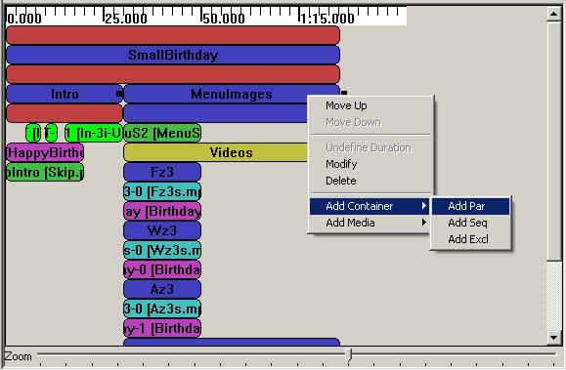

For example if you create a Par, a window like this will be displayed:

Now you can set the new Par properties and create it by clicking on “Ok”, you can also cancel the creation by clicking on “Cancel” or exiting the window. See section 6.3.3.3 for details about the Containers properties.

Add Medias

To add a Media to a Container right click on it and select the submenu “Add Media” and choose the type of media you want to add.

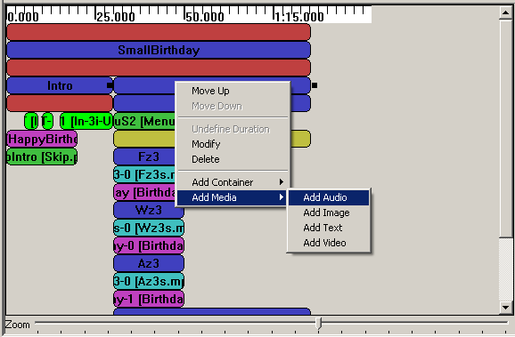

For example if you create an Audio, a window like this will be displayed:

Now you can set the new Audio properties and create it by clicking on “Ok”, you can also cancel the creation by clicking on “Cancel” or exiting the window. See section 6.3.4.3 for details about the Medias properties.

Modify

To modify by dialog a Container right click on it and select “Modify”. A window like this will be displayed.

There you can set the following properties :

Id: ID of the container (default: empty)
The ID is used identify the Container in the SMIL

Begin: Begin of the container (default: not set)
The Begin set the start of the container; it is a list of beginnings. The general definition of W3C is supported:
http://www.w3.org/TR/SMIL2/smil-timing.html#adef-begin

End: End of the container (default: not set)
The End set the end of the container; it is a list of endings. The general definition of W3C is supported:
http://www.w3.org/TR/SMIL2/smil-timing.html#adef-end

Dur: Duration of the container (default: not set)
The Dur set the duration of the container; it is a single Duration value.

RepeatCount: Number of repetitions (default: not set)
The RepeatCount is used when you want to repeat the container a defined number of times.

RepeatDur: Duration of repetitions (default: not set)
The RepeatCount is used when you want to repeat the container for a defined duration.

Fill: Default Fill for Medias in this Container (default: auto)
The Fill is used to set default filling for Medias in the Container. It can have the following values: auto, remove, freeze, hold and transition.

Note: the offset value for Begin, End and Dur can be also set by mouse.

Delete

To delete a Container right click on it and click on “Delete”. A confirms dialog will appear:
Like this one if the Container contains something.

Like this one if not.

In both cases click Yes to delete the Container or Cancel or exit the window if you changed your mind.

Medias

The Medias are the resources played in the SMIL. You can add Link to a Media or select his Region by right clicking on it and using the menu. You can also set timings properties by mouse and by the menu. Medias could be Audio, Image, Text and Video for respective type of files playing.

Add Link

To add a Link to a Media right click on it and click the menu “Add Link”, a window like this will be displayed:

There you can set the following properties of the new Link:

Id: ID of the link (default: empty)
The ID is used identify the Link in the SMIL (used most of time for internal links).

Href: Link to load (default: empty)
The Href is used for external Links by setting a link to another SMIL file.

Title: Title of the Link(default: empty)
The Title is displayed as information when the SMIL is played.

Coords: Coordinates of the Link Region (default: empty= entire Region)
The Coords are a list of coordinates to define a sub-region mouse sensitive to load this link (the entire Region is used if it is not defined)

The Resource button allows setting the Href by selecting a SMIL resource in Axom. It loads a window like this:

You simply select the resource you want to link and validate; the new Href will be set.

Select Region

To select the Region where a Media is played, simply right click on it and click the menu “Show Region”. The Region of the Media will be selected. (in Tree and Visual View)

Modify

To modify by dialog a Media right click on it and select “Modify”. A window like this will be displayed.

There you can set the following properties:

Id: ID of the Media (default: empty)
The ID is used identify the Media in the SMIL

Source: Source of the Media (default: empty)
The Source is used to link the resource played by this Media

Region: Region of the Media (default: first Region)
The Region defines the area where the Media will be played. You can select each region you have defined.

In Transition: Transition at start (default: not defined)
The In Transition defines the Transition at start where the Media will be played. You can select each Transition you have defined.

Out Transition: Transition at end (default: not defined)
The Out Transition defines the Transition at end where the Media will be played. You can select each Transition you have defined.

Begin: Begin of the Media (default: not set)
The Begin set the start of the Media; it is a list of beginnings. The general definition of W3C is supported:
http://www.w3.org/TR/SMIL2/smil-timing.html#adef-begin

End: End of the Media (default: not set)
The End set the end of the Media; it is a list of endings. The general definition of W3C is supported:
http://www.w3.org/TR/SMIL2/smil-timing.html#adef-end

Dur: Duration of the Media (default: not set)
The Dur set the duration of the Media; it is a single Duration value.

RepeatCount: Number of repetitions (default: not set)
The RepeatCount is used when you want to repeat the Media a defined number of times.

RepeatDur: Duration of repetitions (default: not set)
The RepeatCount is used when you want to repeat the Media for a defined duration.

Fill: Filling of the Media (default: auto)
The Fill is used to set the filling for the Media. It can have the following values: auto, remove, freeze, hold and transition.

The Resource button allows setting the Source by selecting a resource in Axom (selected by mime type). It loads a window like this:

You simply select the resource you want to link and validate; the new Source will be set.

Note: the offset value for Begin, End and Dur can be also set by mouse.

Delete

To delete a Media right click on it and click on “Delete”. A confirms dialog will appear:

Click Yes to delete the Media or Cancel or exit the window if you changed your mind.

Example

Introduction

For this small example we will create a little SMIL presentation from scratch. It will demonstrate how to use this editor for a simple interactive presentation.

Basic Files

A SMIL play other files. So we will load the createSMILexample.axm file:

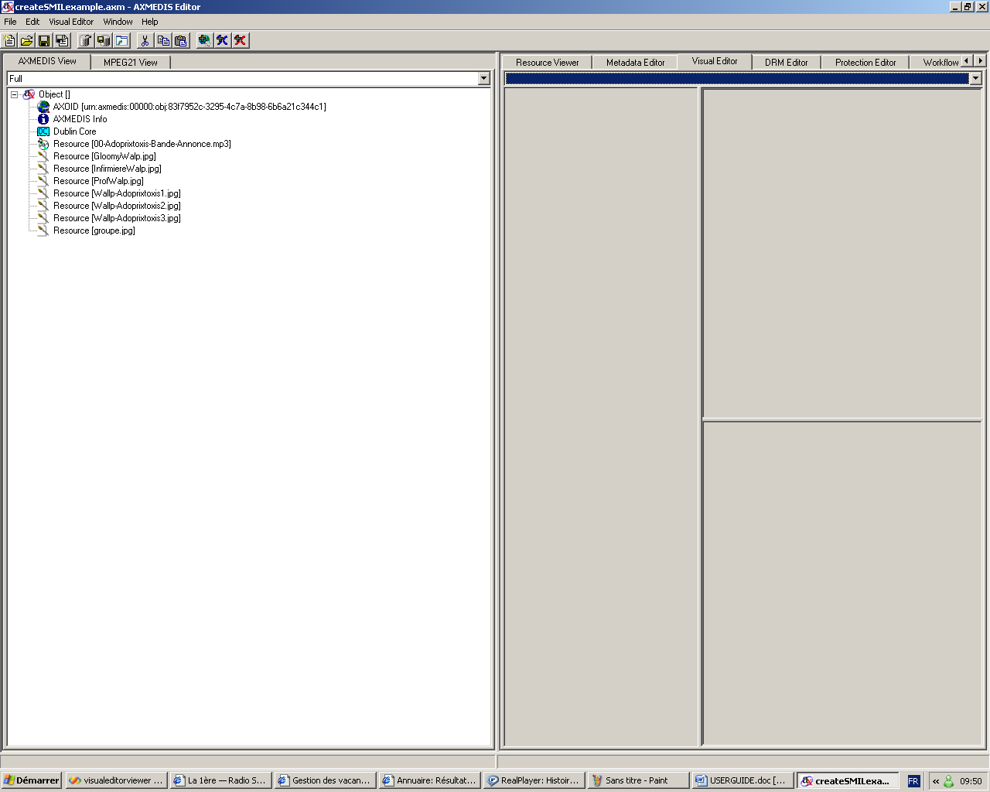

Create the SMIL

Now we have to create a new SMIL Resource. So we use the menu VisualEditor:

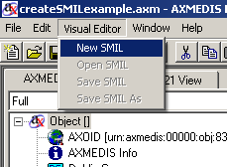

The New empty SMIL appears:
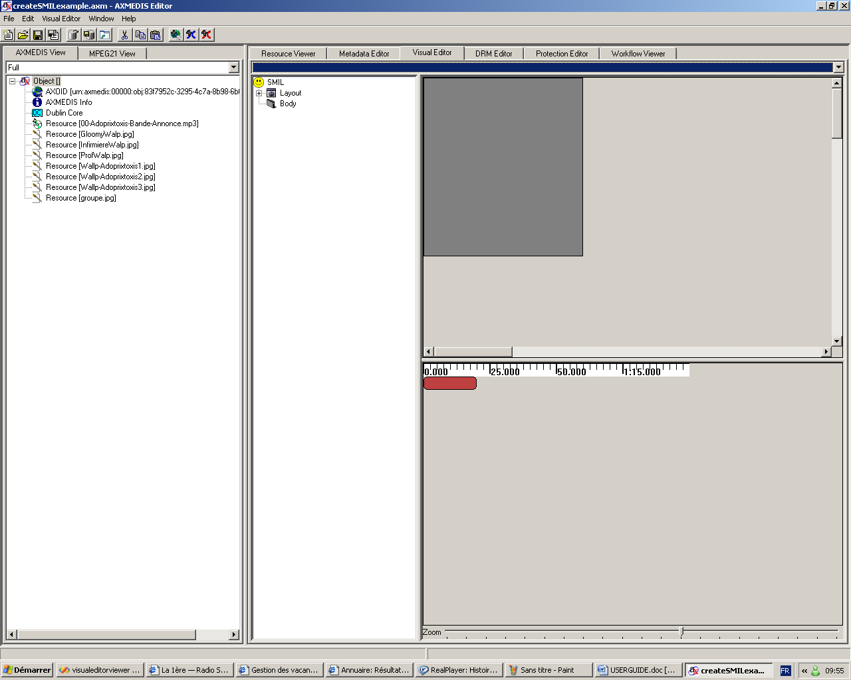

Edit SMIL

Now we can edit our new SMIL resource.

Modify Root Layout

The Root Layout dimensions are not the one we want to use. So we change them:

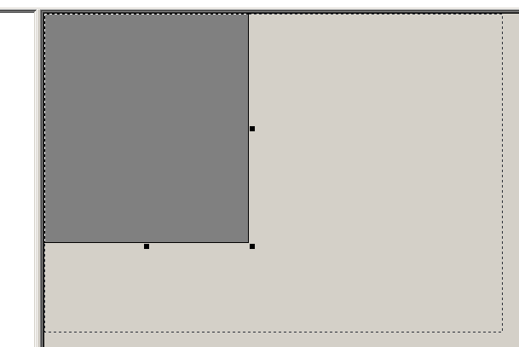

And also by menu…
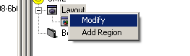
… we change the Color and Adjust the Sizes
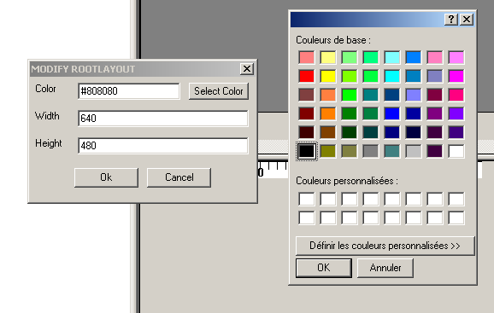

Add Regions

To add the first Region we right click on Layout.

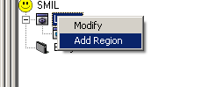

And add a new Region : Audio for Audio playing

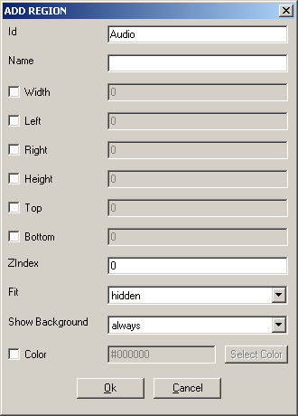

And also another one named Main for Main window.
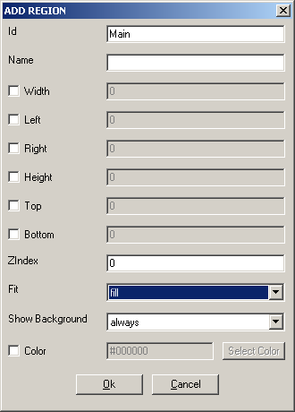

Note that this time we have set the Fit to “fill”.

We finally add another Region in Main:

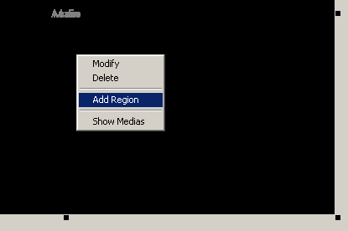

To be a little region in the right bottom part.
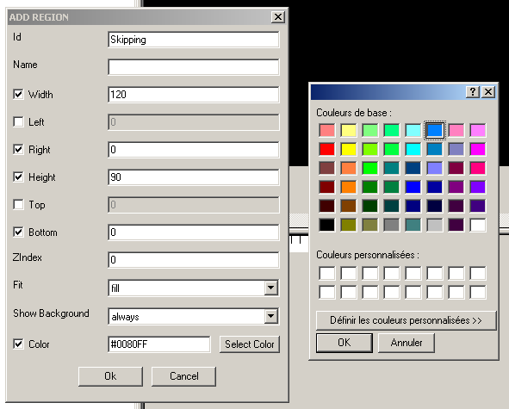

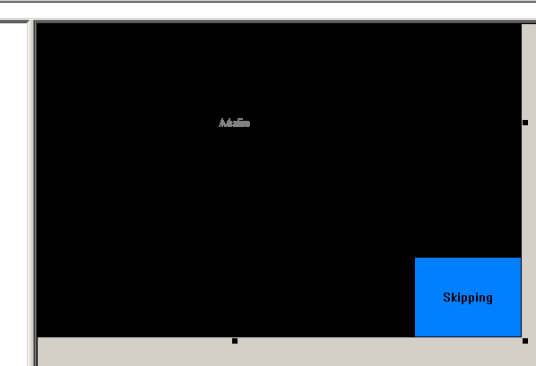

Timing

With the Region defined we can go to the Timing part.

Containers

First we will define some Containers.

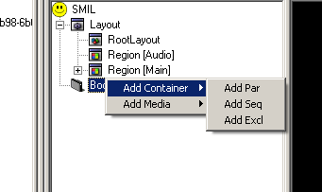

A Par to play sound and images in parallel

And an Excl in it. And 2 Par in the Excl named opt1 and opt2. And finally one Seq in the new Par.
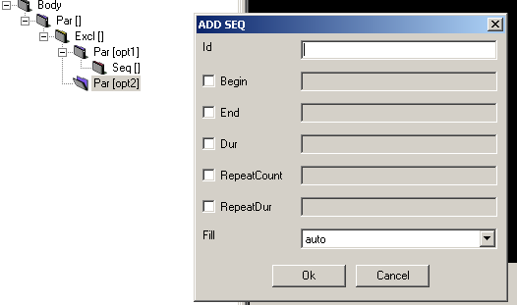

Medias

Now we will add the Medias in the containers.

First we add an Audio Media named sound to play the mp3 file we have in the main Par.

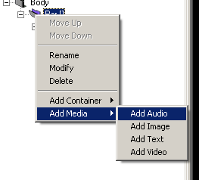
We set the mp3 link by clicking on Resource. And select the Region to be Audio.
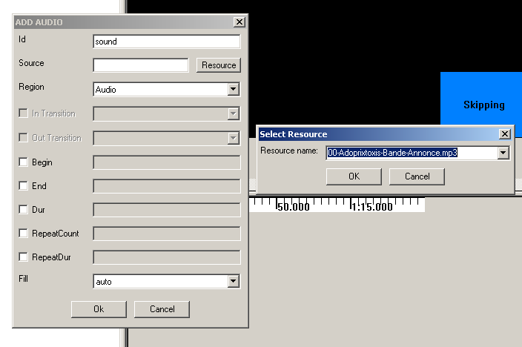

In the two Pars we add the Image groupe.jpg with names skip1 and skip2 in the Skipping region.

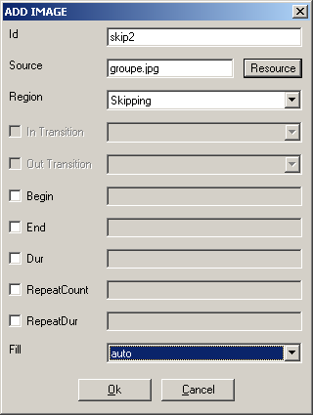
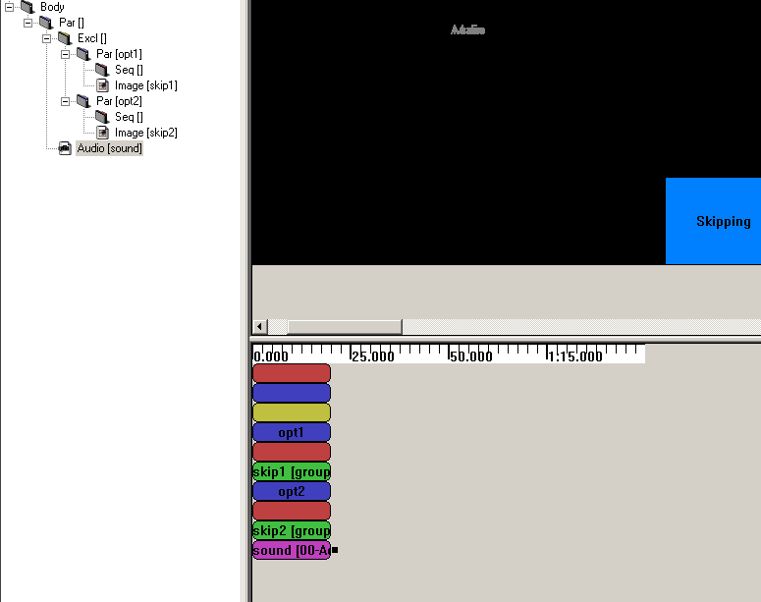

Finally we add images GloomyWalp.jpg, InfirmiereWalp.jpg, ProfWalp.jpg in Main Region in first Seq.
And add images Wallp-Adoprixtoxis1.jpg Wallp-Adoprixtoxis2.jpg Wallp-Adoprixtoxis3.jpg in Main Region in second Seq.

CreatingTransitions

We haven’t defined the Transitions since yet. We add a new transition in the SMIL
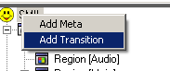
A fading one:
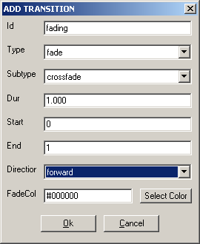

And a fanning one:
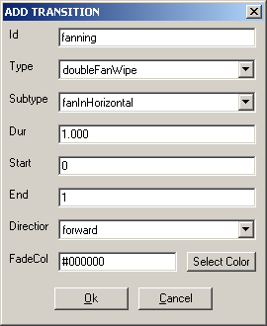

Now we can use these Transitions.

Setting timing

Now we will set Timing properties to our images and a Transition between them.

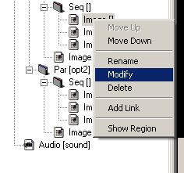
We set all durations to 10 to the images in the Seq and fading transitions between images of the first Seq and fanning to the second one.
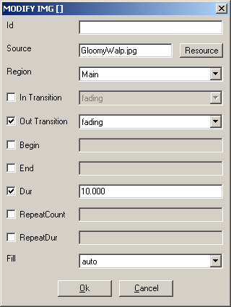

By using the Zoom we obtain a behaviour view like this:
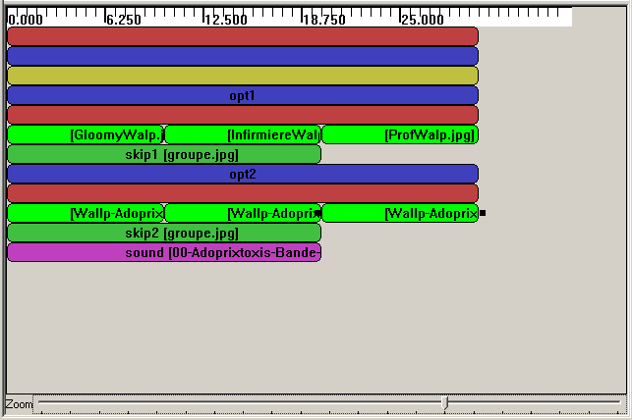

Now we have only to define the start of Par in the Excl. We want that opt1 to be the default and to switch by the skipping. We also take the opportunity to cycle the Par by setting RepeatDur to indefinite.

So we edit opt1:
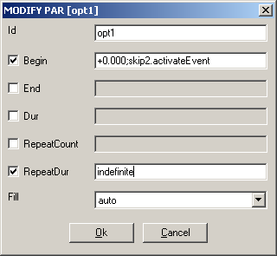

And opt2
: 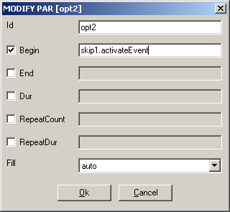

And we add an end to the Excl:
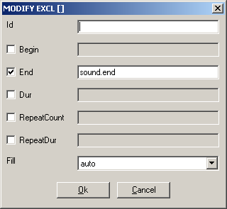

Saving SMIL

Now we can save our work.
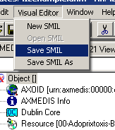
And find an original name.
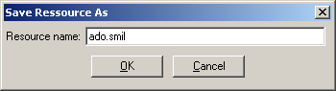

Now you can see it in the Resource Viewer. The image at right bottom is interactive, as set before.

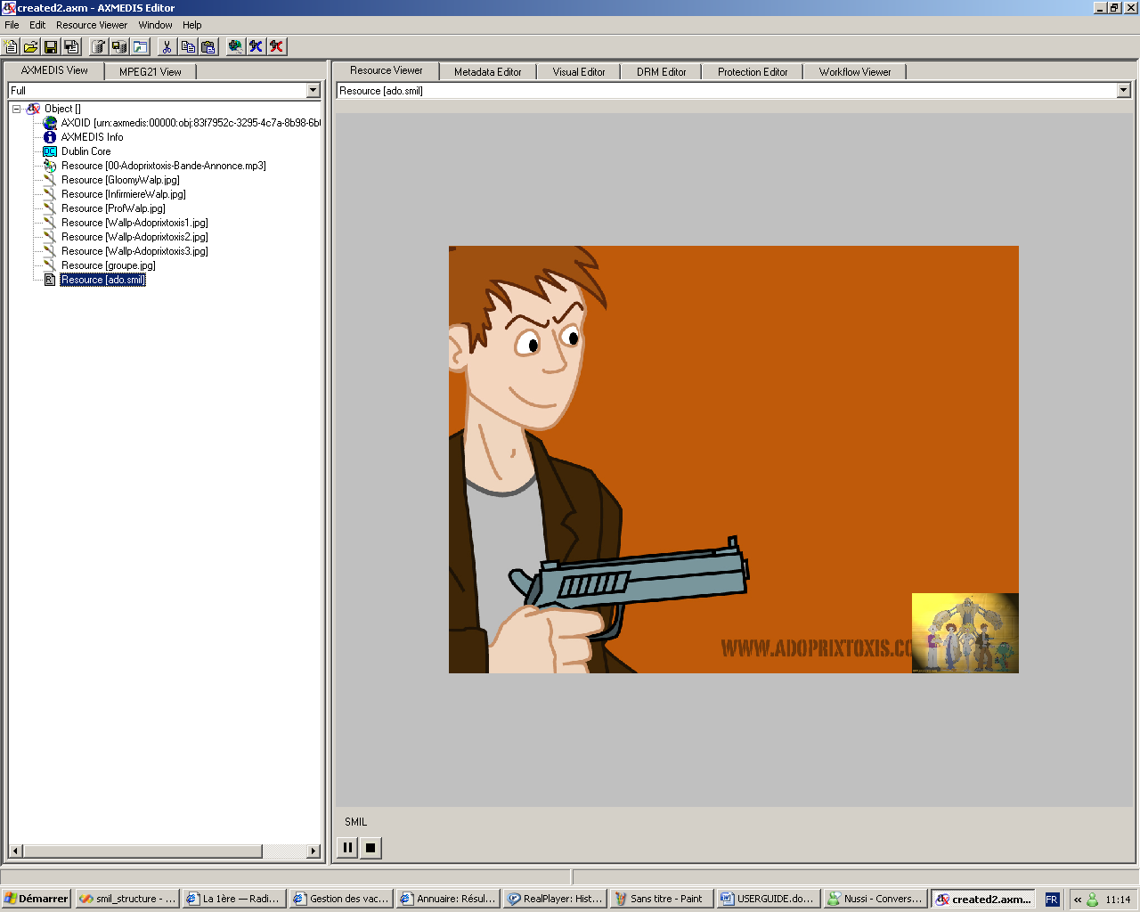

Ok, it is not perfect (and the sound in French), but now can modify it again… It’s up to you now!

