




AXMEDIS

Automating Production of Cross Media Content
for Multi-channel Distribution
www.AXMEDIS.org

DE9.4.4
Integrated Prototype of content production and distribution on-demand for PC

Version: 0.3
Date: 18/04/2007
Responsible: TISCALI
Project Number: IST-2-511299
Project Title: AXMEDIS
Deliverable Type: Public
Visible to User Groups: NO
Visible to Affiliated: NO
Visible to Public: NO

Deliverable Number: DE9.4.4
Contractual Date of Delivery: M30
Actual Date of Delivery: 07 Jen 2007
Work-Package contributing to the Deliverable: WP9.4.1, WP9.4.2, WP9.4.3
Task contributing to the Deliverable: WP9.4.4
Nature of the Deliverable: Documentation for Prototype
Author(s): TISCALI

Abstract:
This is a report on the detailed specifications for demonstrating the content distribution via internet
Keyword List:
Distribution channel, content, mock-up, prototype

Table of Contents

1 Executive Summary and Report Scope 3
2 Introduction 3
3 Prototype for Content distribution via Internet 4
3.1.1.1 Overall use case 4
3.2 Overall Architecture 6
3.3 Internet Distribution via Web – back office - Scenario 7
3.4 Internet Distribution via Web - Prototype 10
3.4.1 Mediaclub Architecture 10
3.5 Mediaclub Website 17
3.5.1 End User subscription to Mediaclub website and AXMEDIS Network - Scenarios 17
3.5.2 Content Search and end user content acquisition - Scenarios 18
3.5.3 Mediaclub Website 19
3.5.3.1 User subscription 20
3.5.3.2 User Portfolio 21
3.5.3.3 Buy a content 21
3.6 Video Demostration 21
3.7 Installation Keynotes 22
3.7.1 CVS coordinate 22
3.8 Fact Sheet 23
3.8.1 Demostrator Functionalities 23
3.8.2 Demostrator Architecture 24
3.8.3 Target Market 25
3.8.4 Description of business model 25
3.8.5 Description of content 25
3.8.6 Final users/client 25
3.8.7 Partners involved and roles 25
4 Bibliography 26

Executive Summary and Report Scope

This document represents an accompanying documentation to the integrated prototype for content production and distribution via Internet as defined in the WP9.4. It contains a description of the prototype for content distribution via internet as specified on DE9.4.1 according with specifications resulting from WP4 and WP5.

Introduction

The main activities done in this WP are detailed specification, integration and finalised research and
infrastructure development for the integration in the AXMEDIS framework of media delivery system for video distribution via web.

The core of this prototype is XAURA, an open, java based Content Management System, that enables to rapidly prototype content applications for the web. XAURA is rapidly being deployed to migrate all the current web properties of TISCALI into a unique global content infrastructure.
XAURA can be adapted to fit most different content schemes. Among specific implementations, a considerable effort has been dedicated to the development of multimedia based services, especially when based on premium content.
All these have been recently unified in a common framework, called the “Media Center”. The Media Center is the main entry point for all audio-video content. It integrates the commercial DRM systems present in the company as well as TISCALI’s billing gateway and deliver infrastructure enabling to provide pay per view, subscription based content packages and other models. Currently the system is working as an experimental service in Italy providing feature movies to TISCALI’s ADSL subscribers.

The main goal is to transform XAURA and the Media Center, XAURA’s main instance devoted to handling multimedia premium content, into stable, documented and fully featured solutions open to integration with all the components of the AXMEDIS project so to enable a complete and easy to use environment for the publication and up-selling of content over the Internet, accessing the content available on the AXMEDIS P2P network AXEPTool.

The functionalities of the system for content distribution toward Internet was mainly split in two groups. The first one describes all back office functionalities provided by the system while the second one describes the functionalities exposed to the end user.
The back office main functionalities are the following one:
- Content acquisition within the AXMEDIS P2P network (using the AXEPTool the mediaclub manager to search for new content in the network (AXMEDIS Network) acquire a distribution license for this content (off line step in the first stage) and add the content acquired to the mediaclub catalogue
- Content acquisition within the AXDB (interfacing the Query Support tool the mediaclub manager to search for new content in the AXMEDIS Data Base, filtering the search by PAR (Potential Available Rights) acquire a distribution license for this content (off line step in the first stage) and add the content acquired to the mediaclub catalogue
- CRM services: using the (AXMEDIS CAMART and AII) for reporting and customer caring purposes

The front-end main functionalities are:
- catalogue browsing;
- user registration,
- content purchase process
- content/license acquisition operation (interaction between AMEDIS Player, PMS and Distributor)

Prototype for Content distribution via Internet
The prototype presented is dedicated to video content distribution such us movies, music clips, reportage, serial, so all use cases, and scenarios are described thinking on this kind of distribution needs

Overall use case

Media Club Manager

MediaClub Manager interacts with AXMEDIS world in several ways during is day by day operation.
MediaClub Manager is the actor mainly devoted to the back office activities. He uses:

- AXEPTool: to search and download new AXMEDIS Objects from the AXMEDIS P2P network;
- MediaClub: to select and edit AXMEDIS Objects to upload in MediaClub System;
- Xaura2: to manage web site contents and axmedis resources that will be ofefred to the enduser;
- CAMART: to extracts the information related to the usage of AXMEDIS Objects, through AII, and make decision on new media content behavior that have could be presented to the end user in the future.

End User

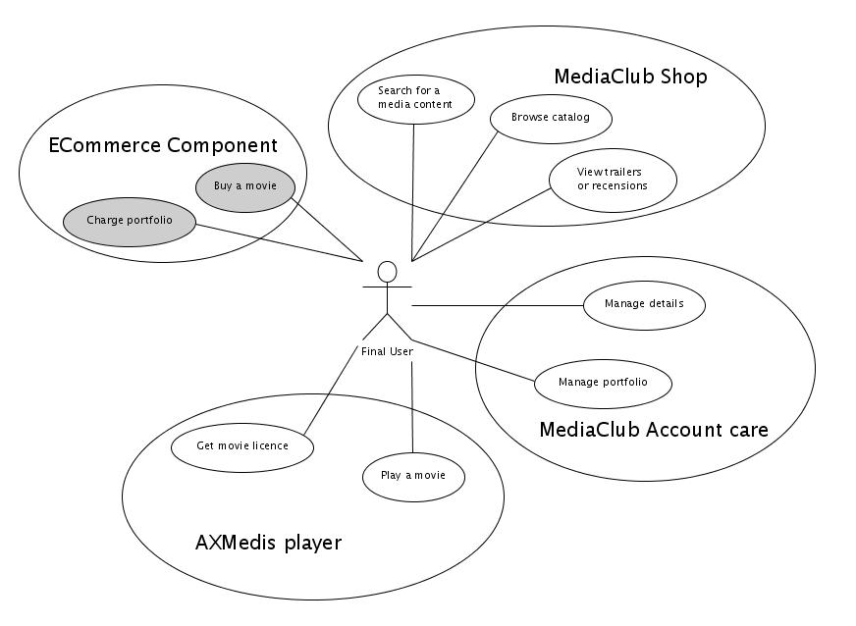

MediaClub final users:

MediaClub users could interact with Media Club web site in several ways through different tools.

- MediaClub shop
Into MediaClub Shop the user can
- browse the media catalog, following links proposed by Content Managers
- search for a specific media content, by inserting metadata details into the provided search tool
- view trailers and read recensions in order to decide about buying a media content

- MediaClub Account Care tools
Using this tool the user can:
- manage its account details and preferences
- manage its portfolio

- Ecommerce Component
Into Ecommerce Component (see par. 4.3.6) the user can:

- charge its portfolio
- buy directly a media content

- AXMEDIS Player
Using AxMedis Player the user can:
- get licences for bought contents (through special MediaClub pages)
- play bought contents

Overall Architecture
The picture below summarize the Tiscali’s Media Club main components for internet distribution.

The internet distribution system core in based on a Content Management System (CMS) called Xaura2 that allow the “Media Content Manager” to organize contents in it’s own catalogue (media file, description, price,etc) and give it available for internet distribution (Media Portals).

Over the Xaura2 system the others component that combined to create the distribution-to-internet system are:
- Media Club AX Plugin – A Xaura2 Component that shall interfaces the AXMEDIS platform, enabling and encapsulating AXMEDIS operations; retrieve catalogues, search for content, download media, permissions, etc
- AXEPTool – An AXMEDIS system that is required for the database (AXDB), search and storage services it offers
- Xaura Media Repository – The media content repository enhanced to support AXMEDIS content too.
- MediaClub Portal – The web site portal offering media contents, managing media contents, end user subscription and profile, user portfolio, etc.
- MediaClub E-Commerce – Payment gateway system, integrated with the MediaClub Portal to allow content payment to the end user
- MediaClub Downloads – Allows the and user to access to the media content offered in the MediaClb Portal.
- AXMEDIS CS – Is the “AXMEDIS Certified Supervisor” here integrated to register new users in the axmedis network or verify if the user is still an axmedis user
- AXMEDIS PMS – Is the “AXMEDIS DRM” to release to the end user licenses for AXMEDIS contents
- AXMEDIS CAMART - Is the AXMEDIS accounting management and reporting interface

Internet Distribution via Web – back office - Scenario
The prototype developed is mainly focused on the functionalities needed to cover the following two scenarios:
- content acquisition from the Axemdis B2B network;
- the axmedis object end user delivering.

Scenario 1: Content acquisition from Axmedis Network
- The Distribution Manager (DM) submit a query search (via AXEPTool) to find contents that should be proposed to the web site users. select content and import data in the distributor CMS.
- DM analyze the query result and select contents to import in the distribution CMS.

The following sequence diagram summarize the actions taken and the prototype components involved in the scenario described:

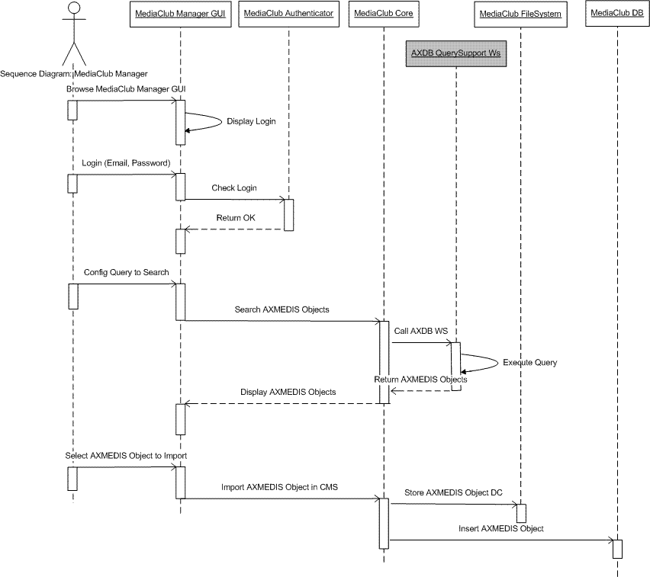

Scenario 2: Edit and publishing content in the website
- The content is integrated with additional information an published in the web site
- The user, browsing the site, selects, buy and downloads a content available from the list of proposed content.

The following sequence diagram summarize the actions taken and the prototype components involved in the scenario described:

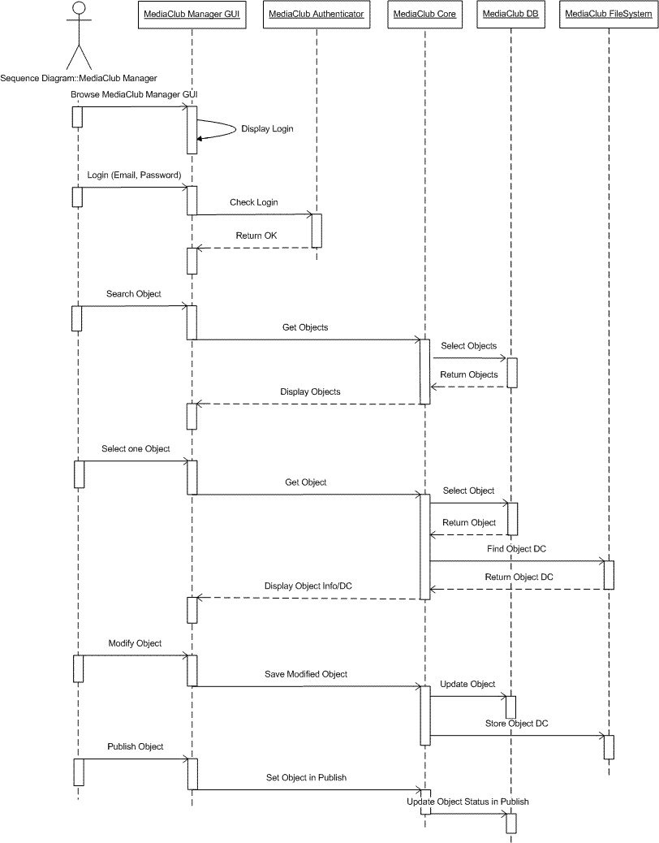

Scenario 3: reporting through CAMART and AII
- Reporting information for accounting and billing pourposes are are retrieved from CAMART
- Reported information are integrated in the administration system for business purposes

The following sequence diagram summarize the actions taken and the prototype components involved in the scenario described:

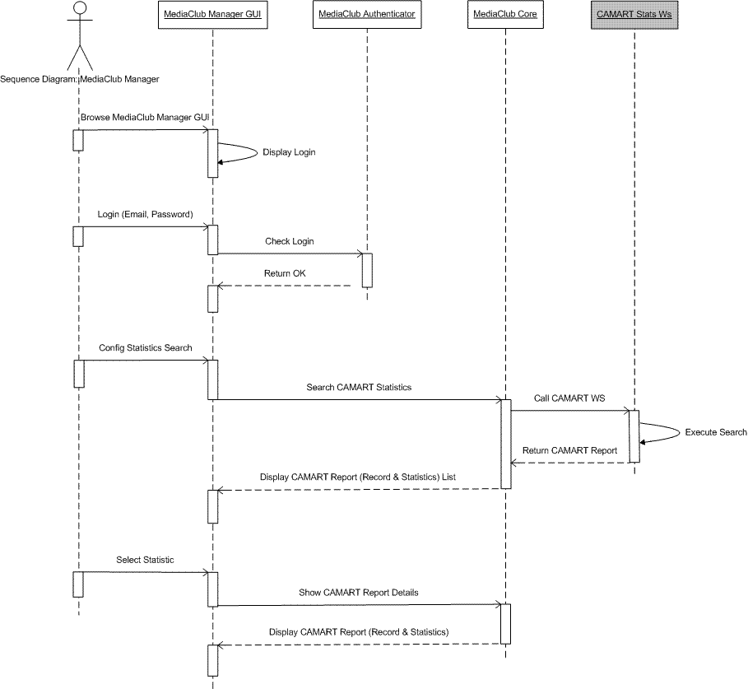

Internet Distribution via Web - Prototype
The prototype does not fully integrate the AXMEDIS framework, although APIs and interfaces are fully identified and specified in the WP 9.4.1.

Mediaclub Architecture

The BackEnd of MediaClub resides into a load-balanced system running a Java Web Application, developed inside a Tomcat Server, connected through a MOD-JK module with an Apache WebServer.

The BackEnd is available over HTTP to MediaClub Manager's Browser.

The persistence of the data is granted from a clustered DataBase and a NetUp fileserver.

The MediaClub Manager's authentication on system happens via MediaClub Authenticator (which uses different modes: Administrator Profiler, POP authenticator, RIPE authenticator).

The communication with AXMEDIS AXEPTool happens via WebServices in HTTP connection.

The Internet Distribution channel prototype performs the following actions:
- search and acquire contents from the AXMEDIS B2B Network via AXEPTool;
- content publication in the web site and distribution to the end user;
- view reports information coming from CAMART

Here below some a brief description of the main functionalities implemented:

Import media
Is the interface for quering contents in the AXMEDIS B2B Network.
Query result example is shown in the figure below.

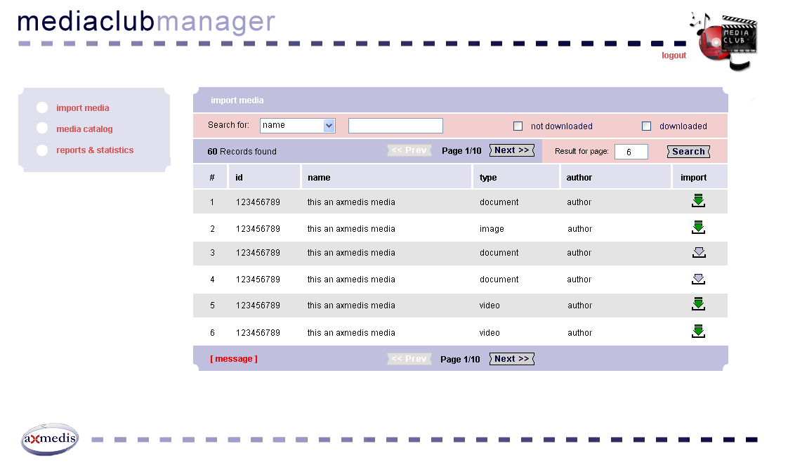

Selecting one of the content listed in the page a content page will be loaded containing all the relevant metadata of the AXMEDIS object selected.
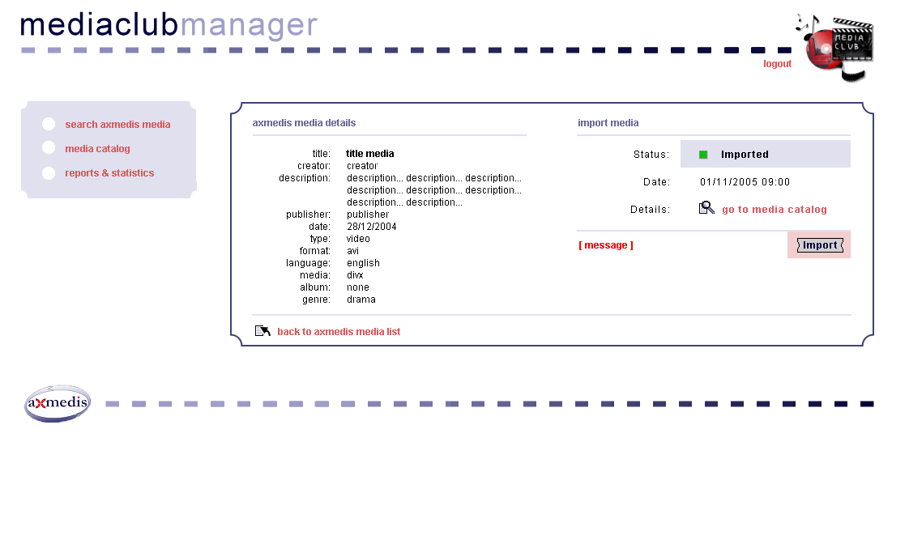

Media Catalogue
From the Content details page the content can be imported in the distribution CMS system (Xaura2). At the end of the import process the media catalogue list page will be loaded as shown in the figure below.

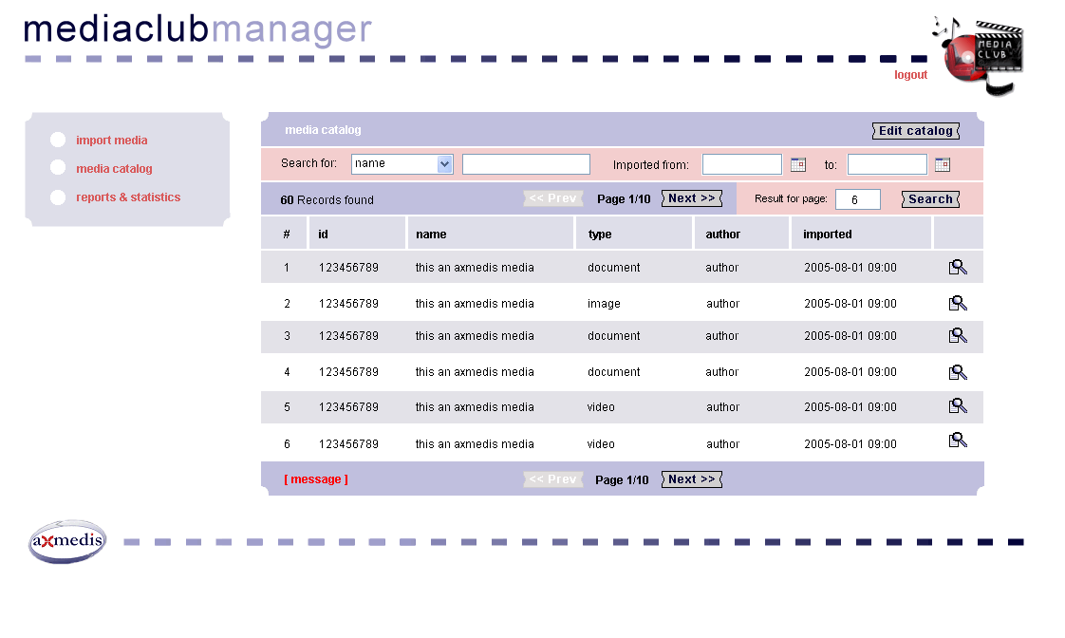
At this stage the content is fully imported in the Distribution CMS and is ready to be managed from the editor to publish the content in the web site.

Content Editing
Once the Editor was logged in, he brows the administration interface using the left column links in the page.
To access to a content the editor brows the left page three clicking in the Content Library folder.

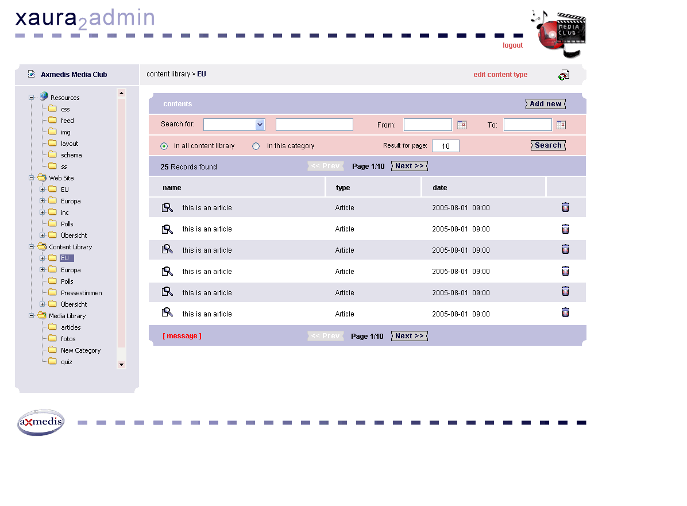

At this stage the editor can search in the catalogue the content that need to be edited and published using the search box or simply browsing the content listed in the page.
Selecting on content the content page will be loaded providing al information present in the CMS for that content.

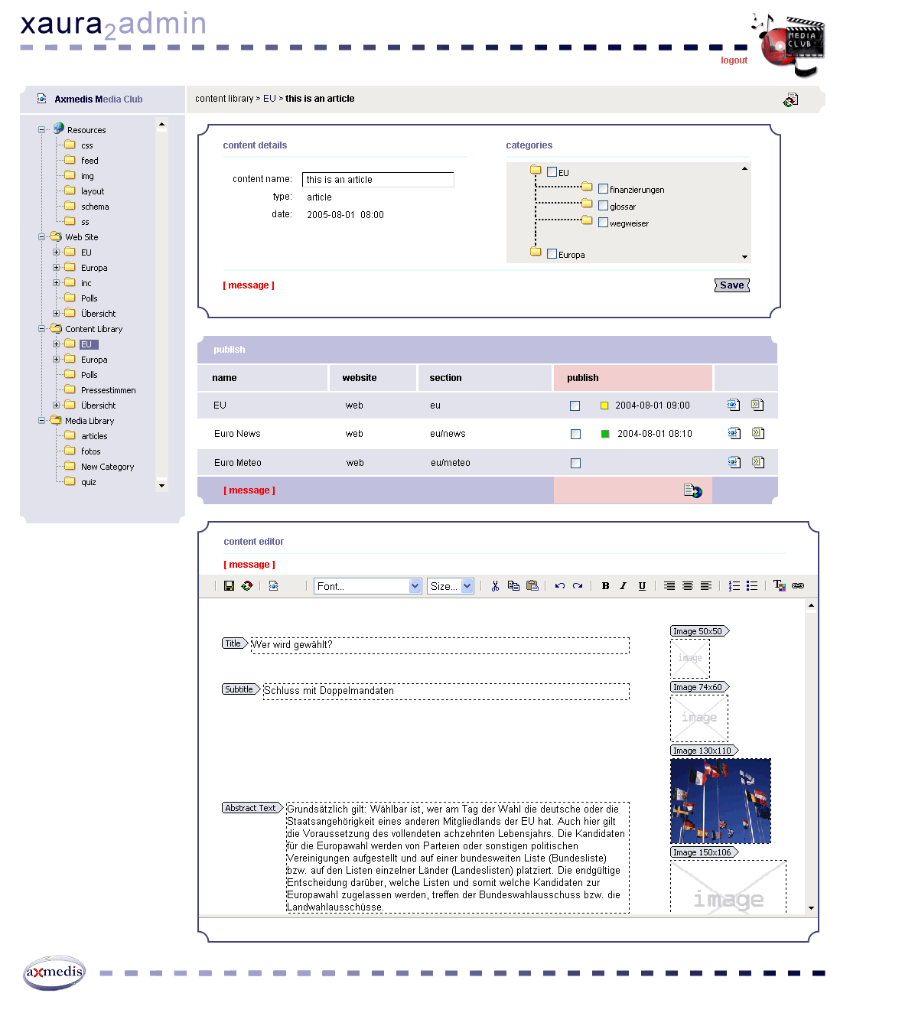
The editor edit the content adding some information like price, assigning the web site categories where the content will be published and, at the end of this process, decide to publish the content in the web page.

Now the content is published and available in the website for the users that can access to it.

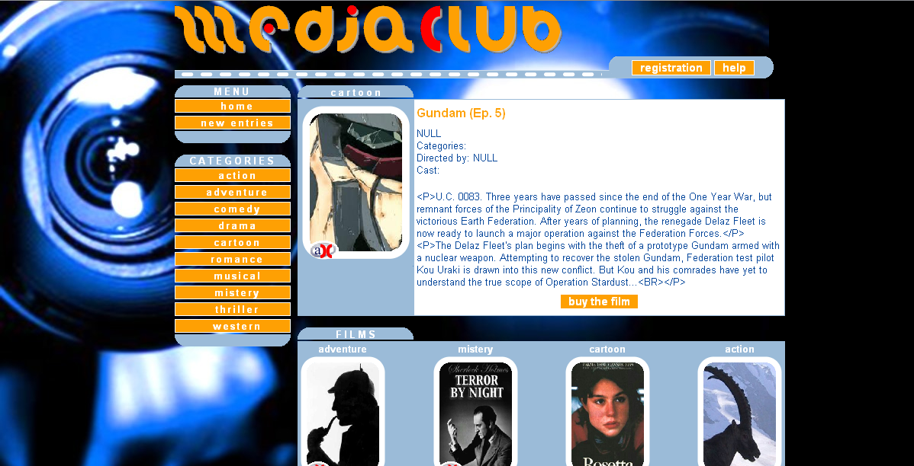

Reports
Is the interface for querying usage contents reports on CAMART.
Query result example is shown in the figure below.

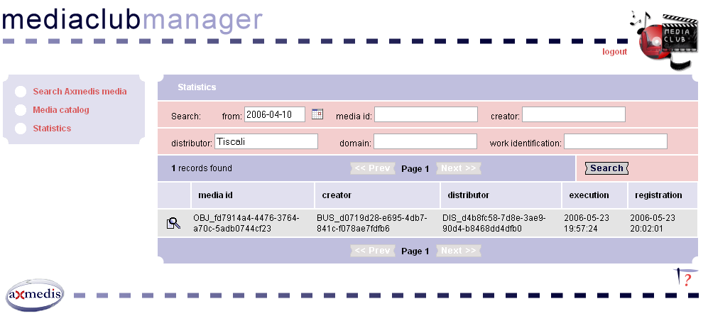
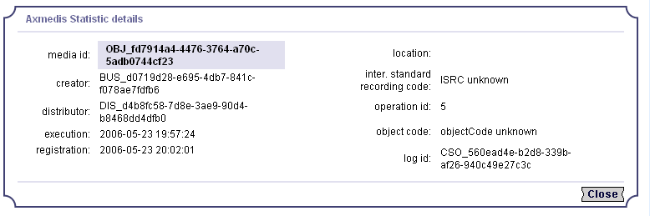

Mediaclub Website
The prototype developed is mainly focused on the functionalities needed to cover the following two scenarios:
- web site browsing, service subscription;
- content search, content selling, content delivering.

End User subscription to Mediaclub website and AXMEDIS Network - Scenarios

Scenario: web site browsing, user subscription in the Axmedis Network
- Subscription is mandatory for mediaclub content acquisition (Axmedis or not)
- During website subscription the user can, if isn’t already an AXMEDIS user, join the axmedis consumer community too

The following sequence diagram summarize the actions taken and the prototype components involved in the scenario described:

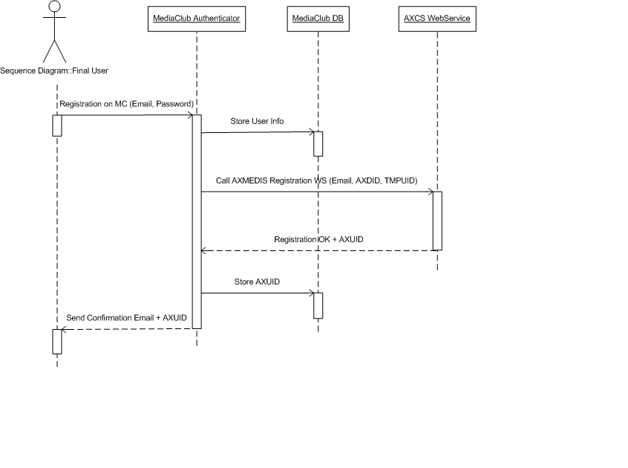

Content Search and end user content acquisition - Scenarios
Scenario: web site browsing and acquistion of axmedis object
- Axmedis user, already subscribed in the mediaclub website too, brows the mediaclub website looking for interesting contents.
- One a content is found it start the content acquisition process (buy a content and download the content to play it)

The following sequence diagram summarize the actions taken and the prototype components involved in the scenario described:

Mediaclub Website

Mediaclub website manage mainly video contents such movies, video clips, …., so according with the increasing diffusion of IPTv and PCTV it is designed to give to the end user “one page experience” like usefull EPGs adopted in the market. This is done to try to maintain the same user experience across the platform (pc web browsing, stb, win MCE, other).

User can browse contents through categories. For each categories the last published content is displayed in the meddle of the page, while other content in the same category can be browsed in the bottom slider.
Axmedis content are automatically identified by the “ax” payload in the bottom left of the image.

User subscription

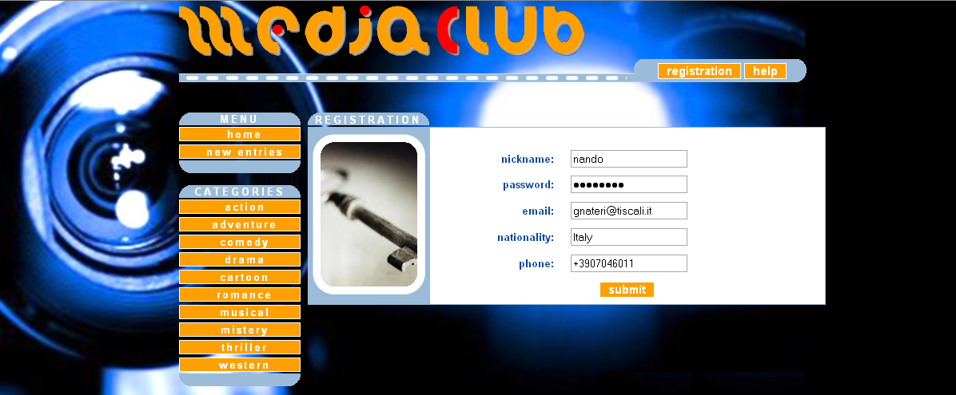

All data requested are the once needed to perform axmedis community subscription too. At the end of the subscription process all information are displayed to the users.

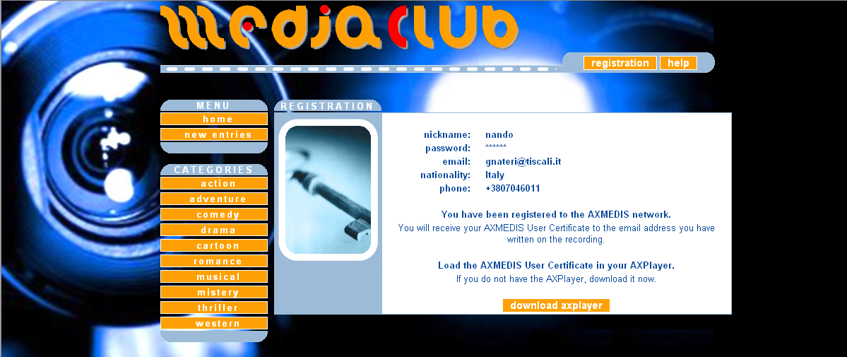

In the subscription success page user is informed that the axmedis user certificate will be sent to his email account with all the steps he has to follow to activate store the certificate in his axplayer.
Axplayer installer is also available in this page

User Portfolio
After login user access to his portfolio page. In this page are listed all content “purchased” and all other information related on the usage done like licence type acquired, numbers of plays already availables and number of plays already burned.
All the information about content usage are directly extracted from CAMART via AII and added in the customer’s portfolio.

Buy a content
Web portal payment system actually fully support pre-pay business model, so user can access to play content only after payment. Internet distributor prototype is integrated to the Tiscali payment gateway (TPG) to perform credit card payment authorization. Users has two possibility to buy content: the first one is the “pay per play” business rule that allow the user to purchase a license when is accessing the content he want to watch the content, the second one is using the web site electronic wallet that allow the user to pre_charge money in his own web site wallet and than use this wallet to purchase content in the web site.
Post paid business model is supported too, this user charge method is not intuitive to show via the demostrator cause the user will not immediately billed so seems that it is accessing to contents for free. However, thanks to CAMART an AII a sort of CDR can be extracted and passed to the company billing system once billing time happens.

Video Demostration
- Internet Distribution of Content (Case and demonstrator)
  - Video on the Distributor point of view (http://www.axmedis.org/documenti/view_documenti.php?doc_id=2126)
  - Video on the End User point of view (http://www.axmedis.org/documenti/view_documenti.php?doc_id=2124)

Installation Keynotes
Installation Package Description
- MediaClub BackOffice
The installation package contains the following files:
      - cms.sql – containing the sql script for the creation of the DB;
      - cms.war (webapp);
      - cms.xml (configuration parameters of the application and the access to the DB), concerning the administration application, to install in the persistent area of the architecture.

- MediaClub Website
The installation package contains the following files:
- mediaclub.war (webapp);
- ROOT.xml (configuration parameters of the application), to install in the persistent area of the architecture.

Installation
- MediaClub BackOffice
    - Creation DB:
- Create the DB according to the PostgreSQL Database Management System procedures (createdb cms);
- Run the script cms.sql.
    - Deployment:
- Create the directory cms in [TOMCAT]/webapps;
- Run in [TOMCAT]/webapps/cms the cms.war file;
- Config the application’s DataSource with parameters to connect DB, created to the point 1), editing the cms.xml file and copy it in [TOMCAT]/conf/Catalina/[host]/;
- Modify the mod_jk.conf file and the virtual.conf file on apache (if apache exists);
- Reload Tomcat.

- MediaClub Website
    - Deployment:
- Run in [TOMCAT]/webapps the mediaclub.war file;
- Copy ROOT.xml file in [TOMCAT]/conf/Catalina/[host]/;
- Modify the mod_jk.conf file and the virtual.conf file on apache;
- Reload Tomcat.

CVS coordinate
The AXMEDIS Cvs repository (https://cvs.axmedis.org/newrepos) contains the installation packages and the javadocs:
- "Applications\mediaclub\AXMEDIS CMS", contains MediaClub BackOffice installation package;
- "Applications\mediaclub\AXMEDIS External Apps", contains MediaClub Website installation package;
- "Applications\mediaclub", contains the javadoc.zip file.

Fact Sheet
The main goal was to transform XAURA and the Media Center into a stable, documented and fully featured AXMEDIS compliant service devoted to the handling of multimedia premium content.
The architecture, fully with all the AXMEDIS components, provide a complete and easy to use environment for the publication and up-selling of content over the Internet. Access to the multimedia content available on the AXMEDIS P2P network will be offered interfacing the system with the AXEPTool.
The current implementation of the Media Center has been integrated with the AXMEDIS framework to obtain an end-to-end solution for acquiring, importing, publishing, up selling and delivering the broadband content that will be available on the AXMEDIS network.
The system is designed to support all main business models for content delivery, like free-to-air, subscription, Pay per view, etc.

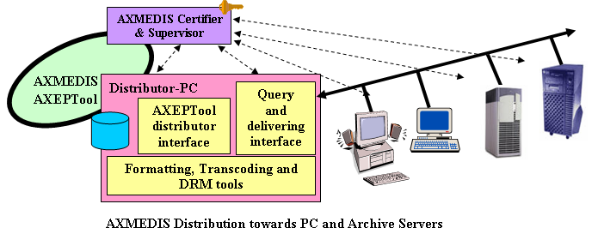

Demostrator scenarios are focused not only on selling content to the end users but even on the services offered to the “Content Distributor” here intended as the actor that is responsible on new content identification. We are mainly talking about the easy way to identify new contents thanks to AXMEDIS B2B P2P network where content producer are publishing their media catalogue offer, and we are talking on AXMEDIS CAMART that can be used for statistical analysis of content usage helping the “Content Distributor” to identify content trends of his web site community.

Demostrator Functionalities
Demostrator functionalities are described in details in the above chapters so in this paragraph a “functionalities summary” is given.
MediaCub Manager can:
- Search content in the axmedis b2b network
- Import axmedis object in the distributor catalogue
- Publish axmedis object in the portal
- Extract axmedis object usage information report from Camart for customer caring pourposes and for new content acquisition purposes

End User can:
- Browse content in the web site
- Join the web site community and the axmedis network community
- Buy axmedis content
- Play the axmedis content
- Download axmedis player

Demostrator Architecture
The demostrator architecture is shown in the two figure below. The first one shows the part involved in back office activities while the second one shows the infrastructure involved in the end-user distribution.
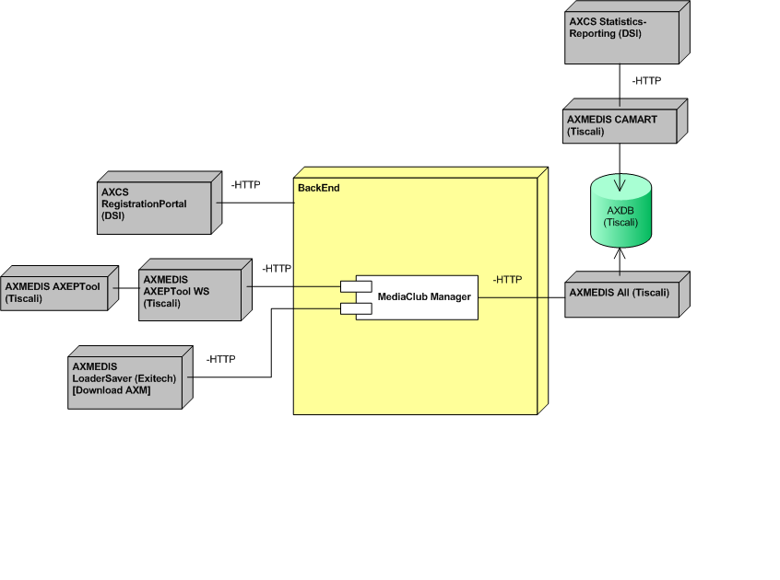

Phisical server are located in the following network nodes:
- Tiscali Cagliari
  - Tiscali Media Club
  - AXMEDIS AXEPTool
  - AXMEDIS AII
  - AXMEDIS CAMART
  - AMEDIS AXDB
- DSI Florence
  - AXMEDIS AXCS (portal/network registration and usage reporting)
  - AXMEDIS AXPMS (end user license creation)
- EXITECH Florence
  - AXMEDIS LoaderSaver (for AXOBJ acquisition)
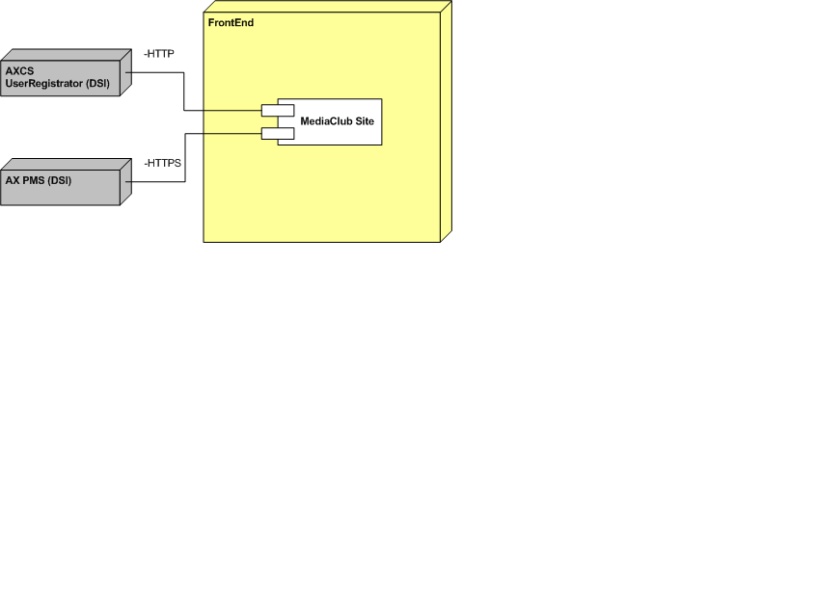

Target Market
Target market of internet distribution prototype is young peoples that consume video content on the web.

Description of business model
During the experimental phase the sequent business model will be presented:
- Pay per play: axmedis object (video) licence will be released to the end user to play/watch the content for a defined number of time
- Pay per view: axmedis object license will be released to watch/access to the object for a certain period of time (i.e. 48 hour)

Description of content
Mainly two categories of content will be provided during the first stage of the trial:
- short movies (about 7 content)
- music video clips (about 7 content)
Video will be provided in windows media format in MBR (multiple bit rate), duration are variable and strictly dependent of content type

Final users/client
During experimental Media club web site will be accessible for about 100 users. The web site will be open to everybody but axmedis object will be accessible only under web site subscription.
In the early stage of the trial web site subscription implies the subscription to the axmedis network too.

Partners involved and roles
DSI
EXITECH

Bibliography

DE 9.4.1 Specification of content production and distribution via Internet.
DE 9.4.2 Mock up of content production and distribution on-demand for PC
DE 9.4.3 First Prototype of content production and distribution on-demand for PC

