Technical Note
n.4510
March 2008

Automate the business process and manage your contents in a more convenient way

Integrate P2P in Multichannel
production and
distribution:
broadcasting,
IP/Internet, WEB sites,
P2P, mobile, IPTV,
interactive TV and
channels, etc.

Exploit Video on
Demand (VOD), IPTV, and production on demand solutions

Control P2P content
sharing and distribution,
involving your customers
in distribution (superdistribution)

Involve your customers
and final users in
content production and
social networking

Integrate interoperable
DRM into your business

Exploit different
business models and/or
transactions on the
same distribution
channels: pay per play,
monthly rate, preview,
renting, advertising, etc.

Exploit interactivity with
cross media models

Adopt advertising
(customized and/or real
time personalized
advertising)
How to exploit AXMEDIS DRM solution in your portal
Before reading this technical note we suggest to read the technical note N.4501 on general aspects of AXMEDIS DRM (Digital Rights Management) http://www.axmedis.org/documenti/view_documenti.php?doc_id=3616

Despite of the AXMEDIS capabilities in managing multichannel solutions, in this technical note a simple solution is presented to show a single instance. In particular, this technical note describes how to integrate AXMEDIS DRM and other tools in order to enforce DRM capabilities for e-commerce of digital content in a Web Portal. Before, to present the AXMEDIS solution, a short overview of the main AXMEDIS components is given; then the requirements of the Portal with DRM integrated are presented.

AXMEDIS DRM Overview
AXMEDIS solutions can reduce costs and increase efficiency of your content management. AXMEDIS supports the whole value chain and provides tools to simplify the convergence of media, the media transcoding, and the interoperability of content enabling multi-channel distribution. AXMEDIS provides a flexible and interoperable DRM, for both B2B and B2C across traditional and P2P distribution platforms.
AXMEDIS Multichannel DRM is an open interoperable solution for protecting and managing rights for a wide range of content, from single files to complex cross-media and multimedia, distributed on different channels towards different type of players and devices. AXMEDIS can be used to setup and manage DRM solutions for:
o Internet, client server and P2P distribution;
o broadcasting, satellite and terrestrial distribution;
o production and video on demand distribution;
o mobile and PDA distribution;
o interactive TV and educational content distribution;
o PC, STB/PVR, HDR, PDA, Mobiles, etc.;
o physical media: CD, DVD, USB, etc.;
o business to business (B2B) distribution;
o integrated business to business to consumers (B2B2C) distribution models.

AXMEDIS DRM Architecture and Solution
AXMEDIS DRM architecture has been designed to be easily integrated into any distribution channel, allowing you to maintain your front end distribution solution and customer relationship management tools. In the following figure, the green parts are your servers and your customers/markets; grey and light blue parts are those that can be provided by AXMEDIS or in which AXMEDIS parts can make the difference with tools.
AXMEDIS DRM exploits and extends the MPEG-21 standard allowing to:
o protect any content formats and types:
- video, audio, images, documents, games, etc.;
- cross media and multimedia content: HTML, SMIL, MPEG-4, etc.;
- collections and combinations of the above mentioned content formats;
o control the exploitation of rights of the above content formats:
- formalization of rights and conditions with formal content licenses. The license is a digital version of a contract that contains the list of rights (with related conditions) that can be exploited on that content by a given user. In AXMEDIS, licenses are formalized in MPEG-21 REL Standard;
o collect and report information about consumption of rights for
- accounting, billing and/or statistical analysis;
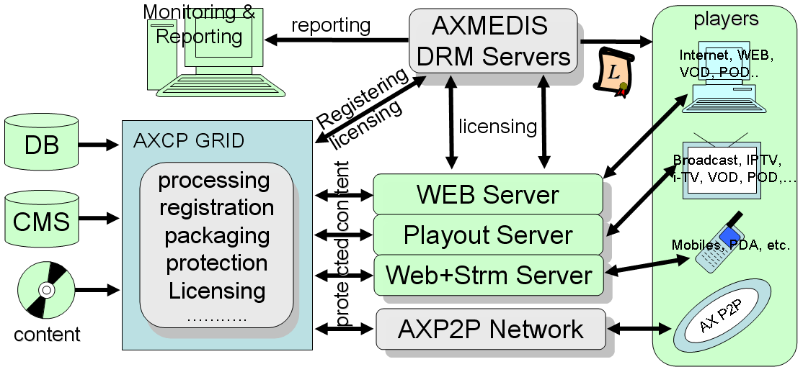

AXMEDIS DRM solution provides you:
- AXCP: tools for content packaging and protection (they may range from simple manual tools to automated tools based on GRID technology, AXMEDIS Content Processing, AXCP solution), and are capable to make automatic registration of users, content adaptation, transcoding, fingerprinting, management, repurposing, licensing, etc., see a summary in the following technical note http://www.axmedis.org/documenti/view_documenti.php?doc_id=3624
- DRM servers for (i) controlling the exploitation of rights of protected content, (ii) collecting information about the exploitation of rights; for example counting the times a given content object has been played, by a given user, on given device, etc. (iii) optionally interacting with an intellectual property ontology to facilitate the production and verification of licenses.
- players for protected and non protected cross media content on PC (MS Windows), PDA (Windows Mobile 5 and 6), STB/PVR (Linux and Kreatel based), and AXMEDIS Java based Mobile. AXMEDIS players can be customized in several different manners and can be hosted in WEB pages (AXMEDIS player in the form of Active X). http://www.axmedis.org/documenti/view_documenti.php?doc_id=3845
- tools for manual and automated production of licenses, and for accelerating the transformation of contracts to licenses directly from the contract text, and vice versa for legal validation of licenses.

Front end content distribution servers, commerce servers, customer relationship servers can produce licenses for your final customers. These licenses are required to be produced posted onto the AXMEDIS DRM Servers via a Web Service call. In alternative, the same servers can use the AXCP GRID to perform the same activity, particularly when there are a high number of licenses produced. For example, in the case of a business model based on subscription; each new subscription produces a set of licenses to enable the new user to access all the content distributed.
As illustrated in the above figure, it is possible to exploit the P2P technology for content distribution by using AXMEDIS P2P Network solution which is fully integrated with the AXCP GRID and AXMEDIS DRM. See technical note on P2P http://www.axmedis.org/documenti/view_documenti.php?doc_id=3612

Digital Contents E-Commerce and AXMEDIS DRM
The main requirements of a distribution Portal for protected digital contents supported by a DRM can be summarized as it follows: The portal:
- is interested in distributing digital content, from Video (for VOD) to audio, documents, multimedia, cross-media objects, collections, to courses and interactive collections, etc., with different DRMs rules and models;
- manages a certain amount of users and objects to produce and distribute content according to the business models formalized with licenses and DRM solution;
- allows final users to execute query, search, browse, download of protected objects and DRM;
- arrange and propose some business models (e.g., pay-per-play, subscription, monthly fee, etc.) with the final user and manages the economical transactions, delegating the payments to a certain lending institutions or via other means;
- when requested, has to produce protected objects and formal licenses;
- has to access to the consumption information for the production of bills or statistics;

This following description shows that the main activities to be undertaken for the distribution of content with DRM from a commercial Portal are:
- Production of protected contents, or anyhow of simple/composed contents starting from single or multiple component (as it happens for cross-media models);
- User registration: the licenses can be produced only for registered users, so that users have to be registered;
- Production of licenses for final users on the basis of one or more business models;
- Fruition of contents by users on some AXMEDIS player;
- Gathering of consumption data about rights and/or eventual statistic data;

These aspects are reported in details afterward.

The depicted solution is based on AXMEDIS DRM and it is based on tools, servers, and licenses formalized in MPEG-21/REL/AXMEDIS (to any further information please have a look at the references at the end of the document).

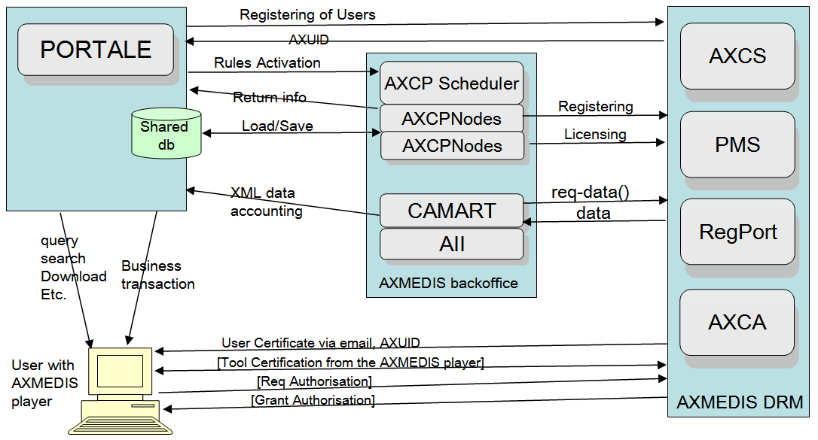

The above figure describes all the interactions between the main parts of AXMEDIS DRM solution: the portal, the AXMEDIS BackOffice and the AXMEDIS DRM Server.

The AXMEDIS BackOffice is based on the AXMEDIS AXCP technology and on instruments to report data collecting as CAMART and AII.
- The AXCP (it is composed by the tools AXCP Scheduler and AXCP Node, and represents a scalable solution). It is able to execute large amounts of tasks in an automated manner; among them the most important related to DRM are: producing protected objects, acquiring non-protected objects form the Portal, registering objects on the DRM server, registering users, production of protected content, etc. The AXCP has also the duty of producing on-demand licenses and sending to the DRM server. At the end of the production, the protected object is sent to the portal. For any further detail please refer to the AXCP Technical Note http://www.axmedis.org/documenti/view_documenti.php?doc_id=3624. If your solution is to delegate the registration to the AXCP, Your Portal will result to be simpler, since it will interact only with the AXCP
- CAMART acquires periodically from the AXMEDIS DRM server reports about the exploitation of rights for all the managed objects;
- AII tool is capable to convert these reports in a manner pursuant to each administration server.
The AXMEDIS DRM section is composed by different parts that can be installed on servers strictly placed close to the Portal, or in remote locations. Going into details a complete AXMEDIS DRM solution includes:
- AXCS: services for object registration, for players operations certification and supervision;
- PMS: services for licenses storing and the production of players authorizations.
- RegPort: registration service for users in the DRM system;
- AXCA: service for production of certificates for users and devices.
A part (or the whole) of these AXMEDIS DRM services can be purchased as services from AXMEDIS or any other AXMEDIS based distributor.

Protected content production
For the production of protected digital contents:
- The Portal may decide which AXMEDIS Object has to be produced, with which metadata, resources, etc. For this aim, the Portal sends the request to execute an AXCP Rule, in this case named Rule A (the description of whom will follow), to the AXCP scheduler (simply named as AXCP into the figure), which on his hand puts in execution the rule on one or more AXCP Nodes as needed;
- It has to be noticed that, the Portal can decide to invoke different Rules to produce different objects: maybe not simply the Rule A, or may invoke the Rule A with different parameters;
  - The AXCP Rules are identified in a unambiguous manner by a proper AXRID (AXMEDIS Rule ID);
  - The AXCP Rules are formalized in JavaScript and installed on the reference AXCP Scheduler to be executed, they can be freely changed according to your needs;
  - The Rules can be produced trough the AXCP Editor that is an integrated development environment with debug and testing facilities.

On the basis of Rule A, the AXCP Produces the protected object according to what the Rule states (it registers the objects on the AXMEDIS DRM, etc.). It may also sends a feedback to the Portal to notify results and AXOID (AXMEDIS Object ID) of the last produced object. The AXCP can send and/or post the produced object in the local Database of the Portal and/or one or more remote databases.

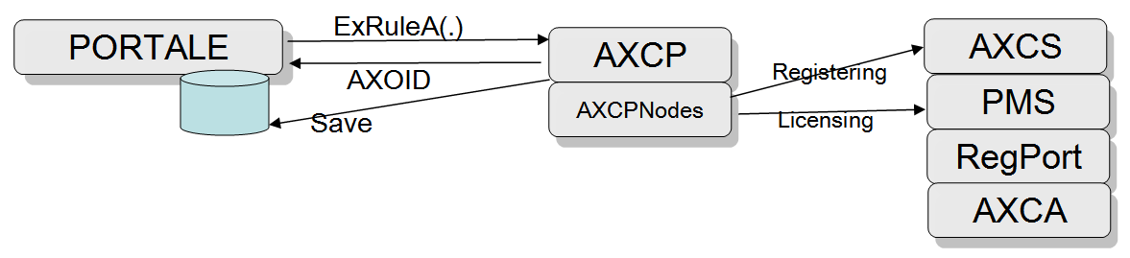
It has to be noticed that, just after its creation and protection, an AXMEDIS Object is not available for the user usage, since nobody has the license to exploit it. In Rule A, it is possible to produce a license, for example a default license, for the producer himself to permitting at least to him to play the object. The portal has to identify or select a certain amount of users to whom release the license for the object usage. These Users have to be registered on the AXMEDIS DRM server and can be identified thanks to their unambiguous AXUID (AXMEDIS User ID). The portal itself has to be registered as Distributor user on the reference AXCS, obtaining its AXDID, that has to be requested to AXMEDIS. Rule A can be aware of the distributor ID, AXDID, to produce and use licenses for the distributor itself.
The AXCP, in the figure, represents the AXCP Scheduler that put in execution Rule A on an AXCP Node of the GRID. The AXCP Nodes can be dozens, or more (at most one on each computer). Their number depends by the complexity of the problem and the workload. The Simplest solution may include a single AXCP Node on the same computer of the Scheduler and/or the Portal.

Remarks
In the case in which the portal is intended to produce protected AXMEDIS Objects through an enrichment procedure (different versions of objects that come one after the other with additional metadata and information added) it has to be noticed that:
- Each new version of the cross media object has to be re-generated each time from the elementary digital resources and from the metadata trough the Rule A, or one of its evolutions, thus producing new objects with different AXOIDs. Then the users accessing to the older version have to receive new licenses to work with the new version of the object.
- The contents can be re-generated from a Rule A with the same AXOID. In this way, the system avoids to re-generate all the licenses for all the different versions of the same objects. This can bring problems in the cases in which the content objects are distributed trough AXOID in an unambiguous manner, as it happens in P2P distributions. In that case, it is recommended to produce a new AXOID each object generation as in the previous case.

Licenses production for final users
The Portal engages the execution of AXCP Rule B (the description of whom will follow) for production of one or more licenses for one or more final users (AXUID list) for one or more objects (AXOID list). The activation of Rule B takes place by the AXCP Scheduler (simply named as AXCP in the following figure). In substance, producing the final license for the one user, the AXDID allows the user identified by AXUID to utilize the object identified by AXOID, according to certain written conditions formalized in MPEG-21 REL/AXMEDIS.

Remark
- The users must be registered and certified. They are identified by their AXUID that must be known and stored into the Portal database, otherwise the Portal should not have all data for production of licenses non-demand or for each category. In a subscription model the collection and management of the user database can be delegated to the AXCP.
- The objects must be protected and identified by their unique AXOID, which has to be known and stored into the Portal database. They are acquired from the feedback of Rule A execution. Otherwise the Portal could not perform the production of specific licenses for such objects, for the identified users;
The licenses are produced on the base of the distributor ID, AXDID. This can be used and coded directly in the body of Rule B. Such a rule uses the AXOID, the AXUID and the information on the business model for the production of Licenses. The Licenses can be produced even by starting from some templates accelerating their production.
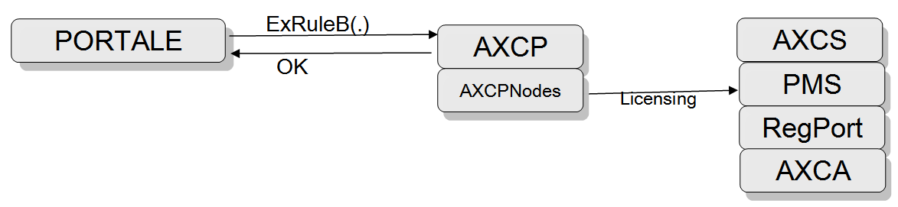
The protected objects can be used by users:
- that are registered on AXCS and thus have an AXUID;
- that own and AXMEDIS player installed and certified, according to the standard procedure for guided certification, and that have installed their user certificate into the AXMEDIS player;
- for whom the Portal has produced a license with Rule B. It has to be reminded that a license is simply stored in the PMS, and the player requests the Grant Authorization for the play (exploitation of right), and it has been given to it, only if the player is certified. These operations are completely transparent for the final user and are automated.

User registration
The user registration can be performed by the Portal (aware of users’ personal data) through and AXCS service or by requesting that service via the AXCP. In both cases the connection is performed via web service command. The AXMEDIS RegPort does not request the knowledge of the personal data and it is finalized to the production of an unambiguous AXUID and User certificate. This solution is always preferable by distributors. In fact, in this way we can avoid the users to reach front ends that are not aligned to the content distribution Portal style, look and feel and services. Another possibility is to delegate the registration to the user, which can access directly on the AXMEDIS Registration Portal.
The registration allows at
- the user and at the distribution to know the proper AXUID, which is sent via email to the user and in response to the WebService call to the distributor. The distributor may delegate the AXCP to make this;
- the user receives by email a certificate that has to be imported into the AXMEDIS player to complete the certification of the player itself;
- the Portal has to know the AXUID of the users registered to produce licenses for them. If the Registration is performed by the AXCP, the Portal could even doe not manage the AXUID.

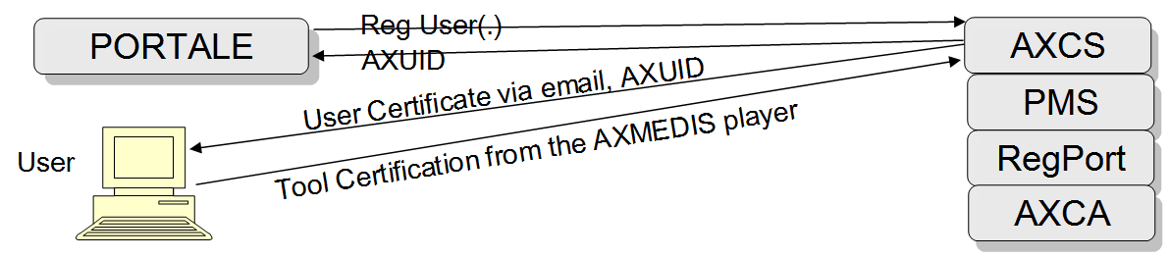

The users receive by email a certificate that they have to put into their AXMEDIS player, and then proceed to the player certification. The player itself guides the user in these operations. In the case in which, they do not perform such a procedure, they will not be able to use the contents licensed for them.

Content fruition
As content fruition we intend the use of an AXMEDIS object by the user. The AXMEDIS content may be obtained (for example via download) by the users, according any transmission channel and modality, therefore that part is not detailed in this document. Furthermore, the user has to establish with the Portal (content distribution service) an business agreement that may imply an economic transaction. AXMEDIS DRM supports different business models concretely formalized in the license production and supported by all AXMEDIS tools.

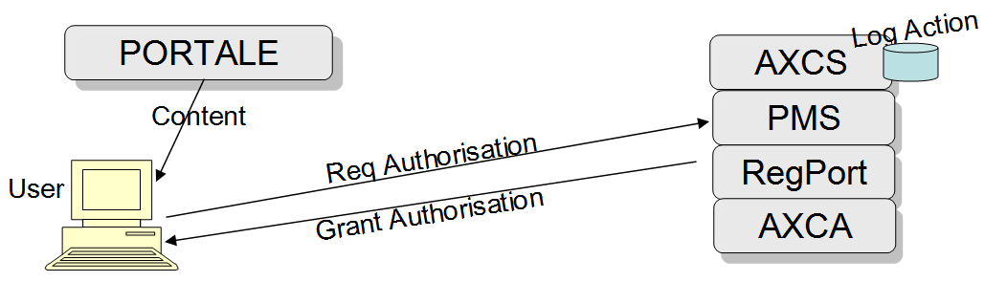

To use the AXMEDIS protected content the users must be registered on AXCS and must have and AXMEDIS player installed and certified, according to a simple certification procedure guided by the player itself. On this line, the Portal needs to produce a license with Rule B. At the moment of the fruition, the AXMEDIS player asks for the Grant Authorization to the AXMEDIS DRM in a transparent manner for the user itself. In the case of authorization, the request is stored as an Action Log (in to the AXMEDIS DRM servers) and the Grant Authorization is released in a transparent manner to the user’s player. AXMEDIS players are available for PC, STB/PVR, PDA, etc. for IPTV, VOD, etc.

For the effective fruition of AXMEDIS content by the final user, it is possible to use one of the several AXMEDIS players for PC, PDA, STB, mobiles, etc. They can be freely downloaded from the AXMEDIS Portal, and at the end of this document the links are reported. Some of those players can be customized to make visible the brand/logo of the distributor. The AXMEDIS Player Active X can be used to integrate the AXMEDIS player into HTML page of the Portal so that to make simplex the integration. For details see the technical note: http://www.axmedis.org/documenti/view_documenti.php?doc_id=3845

Acquisition of Consumption data
This part is optional/additional into the AXMEDIS DRM solution. On the basis of the rights consumption specified into the licenses all the actions performed by the users (Action Log) are stored on the AXCS server. This information can be requested in an automated manner by the AXMEDIS tool CAMART, that can be installed on a remote server, or on the Portal BackOffice. All the information stored by CAMART can be exported through XML into various formats by using AXMEDIS tool AII. A conversion profile can be defined according to the needs of the administrative database. The obtained can be used in producing monthly reports (or reports with different periodicity), or maybe for statistical purposes: for instance to understand the commercial data of a certain songs in a given region or period.
The commercialization of pay-per-play licenses can be performed before the execution of Rule B, for a certain object, for a certain User. This implies that the production of the licenses for the pay per play can be performed typically on demand. On the contrary, the collection of the activities stored (right consumed) into the Action Logs can be useful for producing a monthly and or/bill payment. The access to the Action Log is also of interest to know statistical information about the contents exploitation.

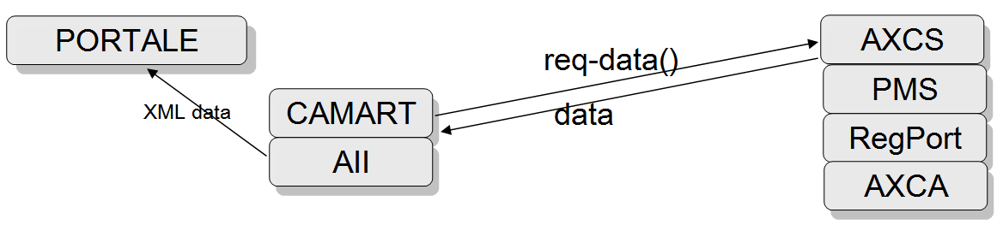

Alternative approach to simplify the integration
As an alternative, the AXCP Scheduler plus the AXCP Nodes can be substituted by a single process executed into an MS Windows Shell to execute directly a single Rule (e.g., Rule A and/or Rule B). This option is advisable only in case in which the Portal presents a light workload, in other words, in the case it is needed to produce a restricted number of objects and licenses per day, hour, or minute. In that case, what has been called previously “AXMEDIS Back office” could be installed completely into the Portal server computer. Thus, when in presence of limited workloads, the AXCP solution (AXCP Scheduler plus Nodes) can be substituted by a single process to be put in execution by the Portal. That process is named as AXCP-SN (AXCP Standalone Rule Executor), and it is capable of executing a single rule for each execution simply with a command such as: “c:\> axruleexecutor.exe Rule A-ID”
If the requests in terms of performances in producing contents and/or licenses are high, the solution based on AXCP allows is a scalable solution which distributes all the requests on GRID Nodes. This can be performed even by activating a rule from the Standalone Rule Executor requesting the execution of other rules on the AXCP Scheduler (realizing in this manner a decoupled hierarchical scalable solution).

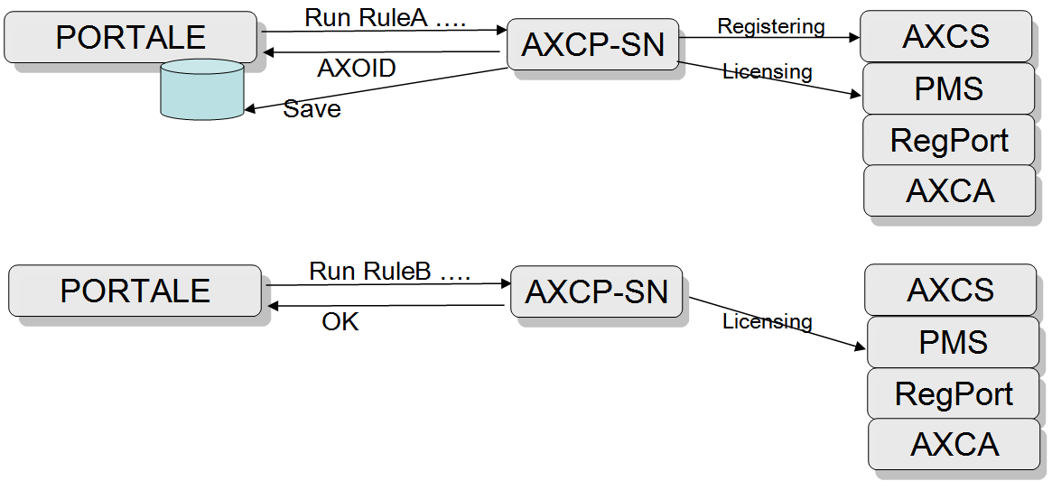

The solution based on the Standalone Rule Executor is certainly simpler and cheaper (in terms of integration development), but at the same time less flexible. It is advisable to start with that minimal and simpler solution, and then to adopt a more complete solution based on a Web Service and an AXCP Scheduler, with one or more Nodes, when the Portal workload grows. Each rule, even if put in execution by the Standalone Rule Executor can produce calls on eventual Web Services or http to communicate the AXOID and/or the fulfillment of the rule itself.

Integration and set up
On the basis of the previous description the introduction is limited to:
- Installation of an AXCP Scheduler/AXCP Node, even also on a single server with a single node. Or maybe of a single Standalone Rule Executer for the execution of rules form the system command line directly on the Portal;
- Installation of AXMEDIS DRM: AXCS, PMS, RegPort and CA (they are MS Windows application). For the first trial phase, it is suggested to use those provided by AXMEDIS and installed in DSI DISIT;
- optional installation of AXMEDIS CAMART and All (they are MS Windows applications) on the Portal Server. They are strictly necessary only when the business model is based on consumption, billing;
- set-up of Rule A for object production. For details and examples related to this aspect, please refer to the following draft in the document
- Set-up of Rule B for license production. For details and examples related to this aspect, please refer to the following draft in the document;
- set-up of a Client Web Service on the Portal to call the AXCP WS Server for the invocation of rules according to the WSDL described in axmedis-de3-1-2-3-6-spec-of-ax-content-processing-update-v1-7.pdf. In case of the solution AXCP Scheduler and Nodes has been chosen, the AXMEDIS Framework collects some WS Clients
  - As an alternative, it is possible to use the Standalone Rule Executor for the execution of a rule directly on the portal, or to call the scheduler from a further rule. In this way, it is possible to avoid to set up the Web Service Client.
- Set up of a Web Service Server on the Portal which has to be called by AXCP Rule for the delivery/reception of ACK and other information such as the AXOID, etc. (please refer to rule A). In the language, in which the Rules are written (JavaScript), there are many facilitations to create a WS Client on the basis of WSDL, so that to call any WS. On AXMEDIS.ORG there are many examples that can be chosen as model to start coding.
  - As an alternative, all the information coming from ACK (notification of a concluded process) or everything else coming from the rules, can be transmitted writing some files in common areas or with HTTP/HTTPS commands, avoiding in this case to set up the Web Service Server,
- Set up of a Web Service Client (on the Portal) calling the AXCS WS Server for user registration according the WSDL described in axmedis-de3-1-2-2-13-spec-of-axcs-and-networks-v1-5.pdf. On the AXMEDIS Framework there are some examples of these WS Clients. This permits at the Portal to maintains and controls the user registration.
  - In alternative, the users can be pushed to make the registration into the AXMEDIS RegPort, avoiding, in this case, to set up the Web Service Client.
  - as an additional alternative, it is possible to delegate a Rule to make the registrations of one or many users on the basis of an object database an User list and business models. In this manner, it is possible to avoid toset up the Web Service Client. This Rule can be executed by the AXCP Scheduler and its nodes or by a Standalone Rule Executor.

AXCP Rule A
Main steps of Rule A:
- rule parameters reading, for example the identification of the resources to be used in the object to be produced, the metadata ID, etc.;
- acquisition from the database of metadata and digital resources of the AXMEDIS object to be produced;
- creation of an AXMEDIS object on the basis of such information:
  - eventual conversion and adaptation of digital resources and metadata into preferred formats;
  - eventual storage of a non-protected AXMEDIS object once produced;
- registration of the AXMEDIS object produced on AXCS and acquisition of the corresponding AXOID.
  - eventual saving of an non-protected but registered object;
- protection of an object with one of the available protection algorithms (automatic communication of protection model and information to the AXCS);
- object saving on disk and/or database, one or more.
  - eventual sending of the object through various communication/distribution channels, as well as the possible publishing on the AXMEDIS P2P;
- production of a mother-license (license that authorizes the distributor to produce final user licenses) and sending it to the AXMEDIS PMS.
  - Eventual production of a final user license and sending it to the AXMEDIS PMS. The child license authorize itself (AXDID) for the exploitation of the content rights;
- Return of the AXOID as a return parameter to the Portal. Return of the completion of the procedure through the invocation of a WS or via an HTTP call, or by writing of a file or database, etc.
This rule can be simply realized in code by starting from those described and available as examples into the bibliography, and on AXMEDIS Wiki portal:
http://www.axmedis.org/tiki/tiki-index.php?page=AXMEDIS+Content+Processing+Scripts

AXCP Rule B
Rule B main steps:
- parameters reading as AXOID, AXIUD, etc. (or lists, located for instance in a file or via XML), business model, and/or kind of license;
- creation of a license according to the business model. For license creation it is possible to start from already prepared templates (it needs just to substitute the user, object IDs and conditions);
- posting of the license on the AXMEDIS DRM (PMS);
- return to the Portal about the completion of the procedure by means of the invocation of a WS or HTTP call, writing on a file or database, etc.
This rule could be realized starting from those available on the AXMEDIS portal. The same rule can also create groups of licenses on the basis of AXOID and AXUID of groups, etc.

General Technical Information on AXMEDIS DRM and AXCP
AXMEDIS DRM is developed to work on MSWindows operating system (some of them can also work on Linux). The AXMEDIS servers can provide: portals and registration services, authority certification (all the instruments and AXMEDIS users are certified, standard X.509), AXMEDIS Certifier e Supervisor (AXCS) and AXMEDIS PMS. Customizations can be produced according to users’ needs.
The AXCP solution is
- capable to work on MS Windows operating system. The AXCP Scheduler and Nodes can be executed on high performances multi-CPU, or even on single computers.
- available as a software solution or as integrated hardware/software solution, ready to be integrated into the Portal.
- reliable, scalable, fault-tolerant. The Nodes AXCP can run many instances of the same rules on the same contents, allowing the set up fault tolerant solutions and the recovery in case of server/disk error. The AXCP nodes are capable if reconnecting automatically to the server after interrupt of connection. They can be allocated in a local network as remote.
- the state of the AXCP Scheduler is continuously saved allowing recovery of the latest stable status.
- scalable for what concerns the number of the nodes and AXCP schedulers. It may work on a single computer, as well as dozens computers both industrial and desktop. Each note can share the file system and the access to the network and databases.

AXMEDIS Affiliation and Adoption
AXMEDIS has been adopted and currently trialed by several industrial partners, who have expressed their appreciation (see http://www.axmedis.org/ibc2007/). AXMEDIS is open and allows you to access source code, reports, technical support, training days, tutorial material, technical notes and documentation, by means of the affiliation program. AXMEDIS consists of over 38 partners (such as: TISCALI, EUTELSAT, Telecom Italia, TEO, ELION, HP, BBC, Giunti Labs, AFI, ACIT, EXITECH, XIM, SIAE, SDAE, etc.). AXMEDIS allows you to exploit innovative results with new tools and solutions for your needs.
References
- AXMEDIS Affiliation: http://www.axmedis.org/com/index.php?option=com_content&task=view&id=12&Itemid=39
  - Affiliation document: http://www.axmedis.org/documenti/view_documenti.php?doc_id=1751
- AXMEDIS General overview and Tools , Flyer on General Overview: High-quality, Low Quality
  - Slides: 100 and more reasons to adopt AXMEDIS
  - Video: Flash executable, 100 and more reasons to adopt AXMEDIS
  - Report: AXMEDIS Framework for all, an overview of AXMEDIS
  - Slides on: AXMEDIS overview at the last USER GROUP meeting, July 2007
  - Slides on: AXMEDIS INTEGRATED DEMOS shown at the last USER GROUP meeting, July 2007
  - Video of: TEO VOD distribution on Kreatel STB with AXMEDIS MPEG-21
  - Video of: BBC trial of AXMEDIS, content recording and production
  - Video of: AXMEDIS MPEG-21 STB/PVR of MBI, July 2007
  - AXMEDIS PC Player: AXMEDIS Player for PC, MPEG-21 player, SMIL, HTML, MPEG-4, cross media, more than 200 file formats
  - AXMEDIS MultiSkin PC Player: AXMEDIS Multiskin Player for PC, MPEG-21 player, SMIL, HTML, MPEG-4, cross media, more than 200 file formats
  - AXMEDIS ActiveX and .Net PC Player: AXMEDIS Active X Player for PC for Web Pages, AXMEDIS .Net Player, MPEG-21 player, SMIL, HTML, MPEG-4, cross media, more than 200 file formats

- AXMEDIS Content Processing Tools
- Technical Notes EN on: AXMEDIS Content Processing GRID all features listed
- Technical Notes IT on: AXMEDIS Content Processing GRID Tutte le caratteristiche descritte
- Flyer on: AXMEDIS Content Processing GRID, AXCP
- Examples: A collection of AXMEDIS content processing scripts for the automated content production and backoffice management
- Manual: AXMEDIS Content Processing GRID Script language user manual
- Development Tool Kit: AXMEDIS Plug in Development tool Kit with examples (for creating your content processing and protection tools)
- Tutorial on: Content Processing, HOW TO Automatically produce AXMEDIS objects from your CMS
- AXMEDIS Content Production Tools: AXMEDIS editor and GRID AXCP tools, PnP, DRM editor, etc., all what you need to create AXMEDIS objects and process any kind of content manually and automatically: SMIl, HTML, content adaptation,, fingerprint, crawling, indexing, cms, search, retrieval, control of P2P, etc.

- AXMEDIS P2P Network Tools
- Technical Notes EN on: AXMEDIS P2P Controlled network all features listed with cases
- Technical Notes IT on: AXMEDIS P2P Controlled network tutte le caratteristiche, con alcune casistiche
- Flyer on: AXMEDIS P2P Controlled Network
- Manual: AXMEDIS P2P tools user manual
- P2P Tool: AXEPTool a P2P B2B tool for B2B, install and join the P2P network of AXMEDIS to get cross media content and TOOLS, tutorials, slides, etc. you can start downloading a file from the P2P with simple click on AXMEDIS portal web pages, look for bittorrent supported files
- AXMEDIS model and Tools for cross media content, multimedia and MPEG-21 Digital Item
- Technical Notes EN on: AXMEDIS Content Model and Tools, Authoring Tools, Players for MPEG-21, PC, PDA, Mobile, STB, PVR, HDR, etc.
- Technical Notes IT on: AXMEDIS Content Model and Tools, Authoring Tools, Players for MPEG-21, PC, PDA, Mobile, STB, PVR, HDR, etc.
- Flyer on: MPEG-21 Editor, MPEG-21 Authoring, MPEG-21 players (PC, PDA, STB, Mobile, etc.) and model
- Examples: A collection of AXMEDIS MPEG-21 OBJECTS that can be authored and playerd by AXMEDIS tools
- Tutorial on: Content Production Tutorial, HOW TO produce AXMEDIS objects
- Report: An overview of AXMEDIS MPEG-21 TOOLS
- AXMEDIS MPEG-21 Tools for DRM
  - Technical Notes EN on: AXMEDIS DRM, MPEG-21 DRM, Interoperable DRM
  - Technical Notes IT on: AXMEDIS DRM, MPEG-21 DRM, DRM interoperable
  - Flyer on: AXMEDIS MPEG-21 DRM
  - Report: An overview of AXMEDIS MPEG-21 TOOLS
- AXMEDIS PDA player
- Tools and demos: AXMEDIS PDA player for AXMEDIS MPEG-21 content please unzip, copy the CAB in your PDA and click to install, the other zip into the zip contains a lot of AXMEDIS objects adapted for PDA including resources with presentations layer based on MPEG-4, HTML and SMIL
- Additional Content: Additional AXMEDIS MPEG-21 objects for PDA: HTML, SMIL and MPEG-4
- Video and demos: AXMEDIS PDA player at work
- SLIDES of the General Tutorial to understand and start with AXMEDIS:
  - Part 1 Video General Tutorial
  - Part 2 Video General Tutorial
  - Part 3 Video General Tutorial
  - Part 4 Video General Tutorial
  - Part 5 Video General Tutorial
  - Part 6 Video General Tutorial
- Content Distribution Tutorial, multichannel distribution

Examples of distribution channels based on AXMEDIS
- Content Distribution via Internet toward PC
- Distribution on Internet the TISCALI demonstrator
- DE9.4.4 Integrated Prototype of content production and distribution on-demand for PC
- Content Distribution toward PDAs and mobiles
- Distribution on PDAs and mobiles the ILABS demonstrator
- DE9.5.4 Integrated Prototype of content production and distribution on-demand for Mobile phones, and new generation of PDAs
DE9.6.4 Integrated Prototype of content production and distribution to kiosks and local PDAs
- Content Distribution via satellite data broadcast (DVB-S) toward PC and STB
- Technical note 6401: "AXMEDIS content via Satellite Data Broadcast"
- Distribution via Satellite data broadcast the EUTELSAT Demonstrator
- http://www.axmedis.org/tiki/tiki-index.php?page_ref_id=422
- DE9.3.4 Integrated Prototype of content production and distribution in push and on-demand for i-TV
- Content sharing with P2P AXEPTool already active:
- http://www.axmedis.org/documenti/view_documenti.php?doc_id=3840
- Content distribution to licensing domains via DVB-T and P2P integration of metadata and additional information
- Content distribution for TV recording, the BBC case:
- Content Distribution toward mobiles based on OMA
- Content distribution with OMA, AXMEDIS back office,
the Telecom Italia case
- IPTV distribution to STB
- Technical note 6001: "VIDEO on demand distribution for IPTV digital set-top-box"
- Content distribution for Video on STB, the TEO case
- Video on Demand, VOD, distribution to PC
- Technical note 6501: "ELION content on demand distribution for PC"
- Content distribution for Video on demand, the ELION case
- Multichannel and multi/interoperable DRM distribution
- AXMEDIS Multichannel Support and DRM interoperability

Contact: Paolo Nesi
DSI DISIT AXMEDIS
Vis S. Marta 3
50139 Firenze, Italy
Tel: +39-055-4796523
Fax:+39-055-4796469/363
axmedisinfo@axmedis.org
nesi@dsi.unifi.it

